Applications: C:\Deepika\Azure Cloud\Angular\DNT363-Sept8-JobInterviewPrep\FormsDirectives\myapp

Application : C:\Deepika\Azure Cloud\Angular\Day5\src -> this was Pradeep class

Guards: Important interview Question

[@angular/cli - npm (npmjs.com)](https://www.npmjs.com/package/@angular/cli)

[TypeScript: JavaScript With Syntax For Types. (typescriptlang.org)](https://www.typescriptlang.org/)

**PRANIT** https://nodejs.org/dist/v18.16.0/node-v18.16.0-x64.msi

https://git-scm.com/

https://code.visualstudio.com/

https://notepad.pw/AngularWeekend

Install typescript using following command

> npm install -g tsc

OR

> npm install -g typescript@latest –force

C:\Users\Deepika>tsc -v

Version 5.0.2

**ng serve -o**

**PRADEEP SHET TOPICS COVERED IN DAY 1**

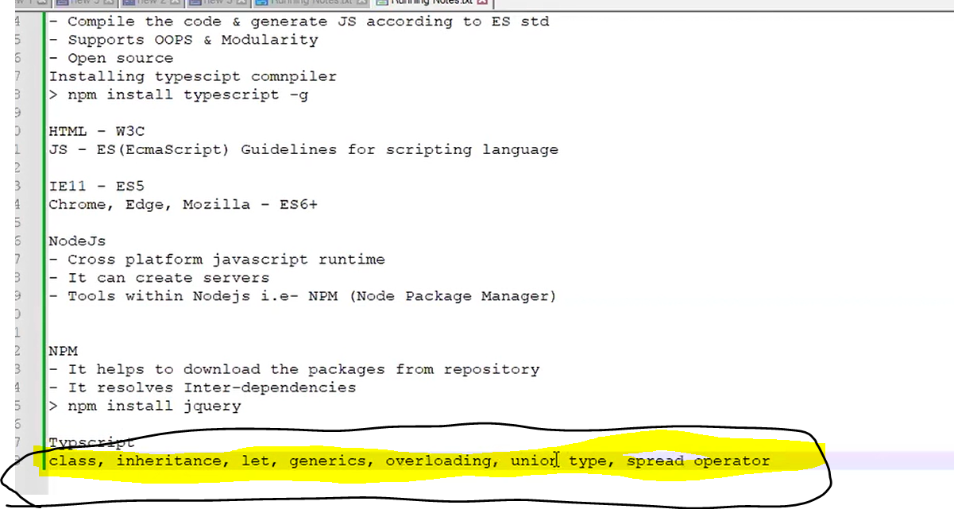

**{{1000| currency:'INR':'code'}}- to print -Rs.1000**

**Do each video for 2 times before session.**

**ng g c category -is --skip-tests**

**Typescript**

Javascript is a dynamic language. It can identify and resolve during run time;

Eg: var i=10; //number

Later I can change i=’str’; //string

Since we are not defining the type; so we can assign new value to the i.

Var j=10;

Var k=10;

Var l=j+k; output=20;

If l=10+10+i; then output=20str;

If =i+j+k=str1010; because str is string; it will consider rest of the numbers as string as well.

Problem: if var is number; it should retain as number always

Function add(x,y)

{

Return x+y;

}

Add(10,20); //output-30;

Add(10);//output- NAN //not a number

Add(); //even if no params; there will be no errors. Its problem 2.

Var i;

Console.log(i); //undefined

Var i=10;

Console.log(z); //null & undefined

//null and undefined;

Null: read a value not at all declared in the code. Therefore, if we run the program, we ll get I is not defined.

Undefined:

Console.log(z); //undefined

//

Var z; //defined later

//so output: undefined

***Hoisting:***Javascript Automatically, move declarations and function calls on top of the program

|  |  |
| --- | --- |
| Undefined--🡪 Hoisting | Null |
| Hoisting = process of scanning the code and moving the declaration on the top.  When js compiles a code.    Variable is called and later have declaration  Eg.   1. Call var i+ j 2. Define var i = 10   Therefore javascript moves the var declaration to the top.  Code will be as follows,   1. var i 2. call console.log(i) //undefined 3. =10 |  |

Typescript helps to maintain a large application.

Issue with Javascript:

* Dynamic typing
* Lack of type safety
* Lack of oops concept like classes and interface
* Lack of modularity🡪
  + eg var a=10; //a.js and console.log(a) //b.js -> we can use var a globally
  + but if we want to stop var a being global ie. Called modularity

**Dynamic typing**-

Javascirpt does nt give error to compile time. Error is in runtime.

**Once we declare a variable; if we change the datatype, javascript will not complain. This will lead to confusion later. Eg. A variable initially declared a number, can be changed to string.**

**Simple words: Scanning the code and moving the declarations to the top ie. Variables and functions;**

Whenever I write a code, Internally a variable is attached to a browser’s window.

To find a control in the DOM Tree -> getDocument.getElementById(‘control name’);

// internally its window. getDocument.getElementById(‘control name’); we are skipping that window keyword.

Type following commands in a browser’s Developer Tools-> Console.

**Dynamic type examples:**

var i=0;

console.log(i);

output: 0

undefined

i="deepika"

'deepika'

console.log(i);

output: deepika

i=1;

console.log(i);

output: 1

undefined

i=5.9;console.log(i);

output:5.9

-----

**Functions**

function add(x,y)

{return x+y;}

add(10,20) //30

add(50); //NaN

add();//NaN

**undefined & null; an important concept;**

**Internally javascript scans the code; the process is called hoisting & moving the declaration to the top;**

There are 2 different things

**1.undefined**

**2.var is not defined**

Scenario 1- undefined:

// internally javascript will interpret as var x;

console.log(x); //**undefined**

var x=10;

Scenario 2 - **var is not defined**:

//if a var is not declared, error occurs namely “var is not defined”;

Console.log(a); // name is not defined;

|  |  |
| --- | --- |
| **Undefined** | **var is not defined** |
| // internally javascript will interpret as var x;  console.log(x); // **undefined**  var x=10; | //if a var is not declared,  //error occurs namely “var is not defined”;  Console.log(a); // name is not defined;    VM914:1 Uncaught ReferenceError: a is not defined  at <anonymous>:1:13 |

Other examples:

var j=10; var k=’Deepika’;

1)var l=j+10+k; //20Deepika

2)var l = k+j+50; //Deepika1050 //reason: initially it prints string then later variable will consider as strings. Therefore it considers the rest to the string and contenates.

**HTML- W3C**

**JAVASCRIPT – ECMA** :script standard allows to create rules for the scripting language.

Eg.ToLowercase() is allowed since its defined throught the ECMA script.

IE 11-ES5(does not accept javascript arrow functions, does not allow javascript classes)

Chrome, Edge, Mozilla – ES6+

<https://www.w3schools.com/js/tryit.asp?filename=tryjs_es6_arrow>

// ES5  
var x = function(x, y) {  
   return x * y;  
}  
  
// ES6- Arrow function : You don't need the function keyword, the return keyword, and the **curly brackets**.

Syntax: **(params) => logic;**

const x = (x, y) => x * y;

const y = ( a , b) => a*b;

**Issues with Plain Javascript:**

* Dynamic type
* Lack of Type Safety
* Lack of modularity

***Typescript : by microsoft***

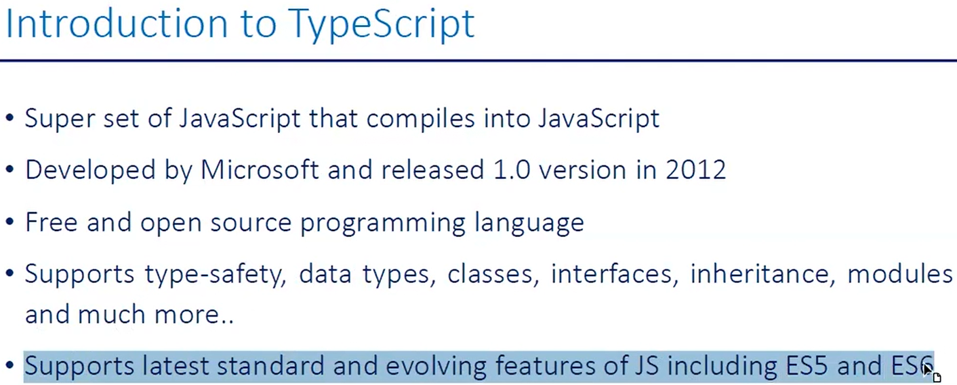

1. -Programming language developed by Microsoft
2. -Superset of javascript
3. -Compile the TS code & convert in to JS according to ES std.
4. Open source
5. -Allows you to follow OOPS, type safety, generics;

Class A{ x:number = 10;}

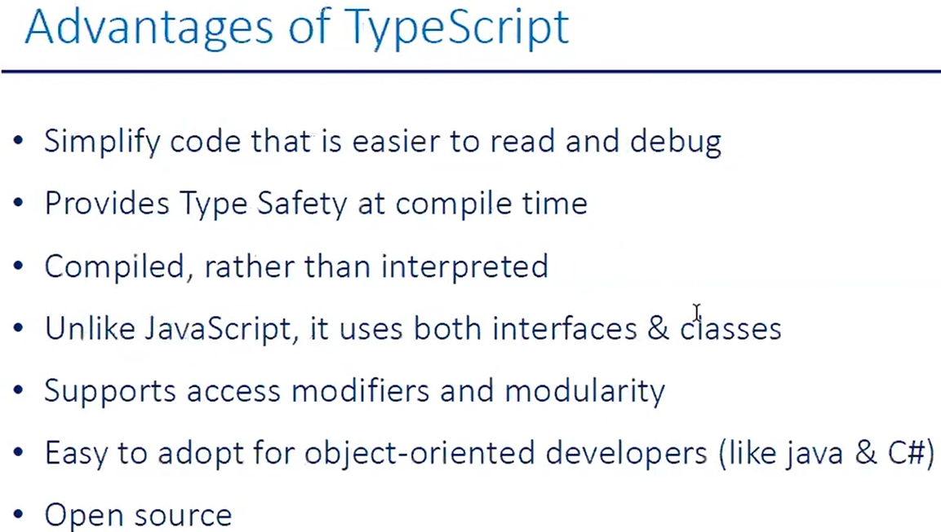Typescript is an open source language that compiles to Javascript. Typescript compiler converts to Javascript code(file.js) according to global standard.

Compiles code into javascript

Typescript is a typed superset of Javascript that compiles to plain Javascript.

Key features:

1. code encapsulation;
2. classes and interfaces //OOP
3. code resuability using inheritance
4. **type support (also support generics, static files and modular code)**
5. **output will be according to ES standard**

Javascript global standard- Ecmascript(ES) -guidelines/ rules defined for JS

ES6+ - chrome, edge, Mozilla, safari

ES5-IE11

HTML- w3c

Advantages of Typescript over Javascript

1)scalable HTML5 client-side development

2)Modular development

3)Easy learning for Java Developers

4)Existing library browser support

5)long term version

6)clean output

**Typescript Code examples:**

var i=10; // in javascript possible

var i:number=10; //in typescript

var j:string="Deepika";

//j=10;//error // not dynamic type

**ANY Datatype :**

**ANY datatype is like a poor guy or begger; beggars cannot be choosers;**

**ANY will accept any datatype;**

**Note: we should avoid any; since it will allow any kind of data but if the code is not handling that it will throw an errors. ( eg, any will allow string or null, but if the code is not handling then it will lead to error). Therefore try to avoid any datatype**

**C# equivalent for ANY**

|  |  |
| --- | --- |
| **C# equivalent for ANY** | **ANY** |
| **Object type**  **Object will take int or string or boolean or null**  Public void function1(object objval)  {  // objval will allow string, int, boolean. So the control will come inside the function1.  // But the code should be able to handle the string or number or the boolean inputs.  //else the code will break  } | Var abc: any =100; //correct  Var def:any=”Shiv”//correct  Var ghi:any=true;//correct  Var jkl:any=undefined; //correct |

**Typescript compiler:**

Typescript files are compiled into Javascript using typescript compiler.

The compiler can be installed as typescript package through npm.

We can compile typescript file using tsc compiler.

**[TypeScript]** -> tsc first.ts -> **Javascript**

**Sources**

https://online-clipboard.online/online-clipboard

.net core Api name: webapi2

Angular: Angular project

**NodeJs**

It is **a Javascript runtime.** But javascript is ran on browser.

Node js provides a runtime so I can run the code without browser. Code can execute Without defining the code in HTML tags. Also I can run on a server.

**NodeJs** :-

1.Cross platform javascript runtime.

2. It can create servers as well. Example discussed Eg. We can have node servers we can have apis in javascript. Node servers created and we

3.Tools within NodeJS ie NPM

**Discussed in detail:**

1. Cross platform javascript runtime.

- file.js file needs a browser to run. Ie. It needs a parent window to load

-Any javascript needs a window or a parent window to run the code.

For ex:- var I =10; is as good as console.log(window.i );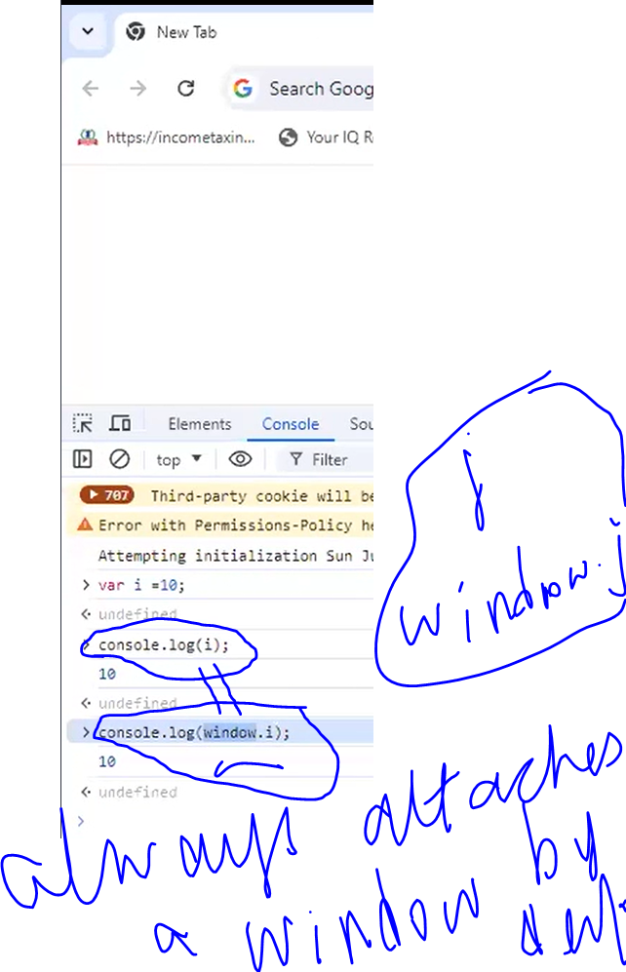

|  |  |
| --- | --- |
| **Javascipt** | **Node JS** |
| The Javascript only allows you to run the code on the clientside; | With the help of Node JS we can run the Type script code in the server as well.  But Node JS allows you to run on the server;  We can host the code on the servers in Node.  **POWERFUL:**  Express JS is a library, used to create an APIs. These APIs run on the NodeJS servers.  When we hit api from browser; it will goto server on NodeJS. It will call API endpoint and load the output.  With the Express JS we can create API that executes using the JS. Ie |

It has node package manager is required to download packages from public libraries

Node package mgr = Nuget package mgr.

**NodeJS:**

**To execute the code: we need Node.**

**Node js is a cross platform javascript runtime. It means javascript to execute it needs a window to execute.**

***Any JS needs a window or a parent window to run the code. Ie window keyword*** .

Internally javascript uses the window keyword.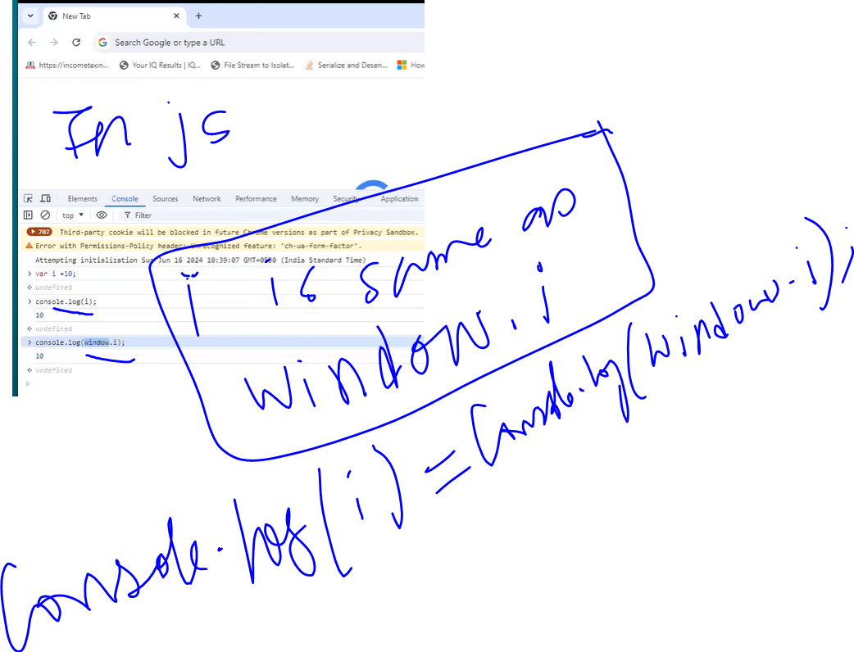

**How to run the Javascript code without the BROWSER?**

IF Node is installed. WE can execute js file

**File execution:-**

>node filename.js

Solution: we don’t need Browser to run the js file

What is a cross platform for Nodejs:- We can run on MAC, Windows, Linux

1. **It can create servers as well.**

Eg. We can have node servers we can have apis in javascript . Image below has node js server port listening.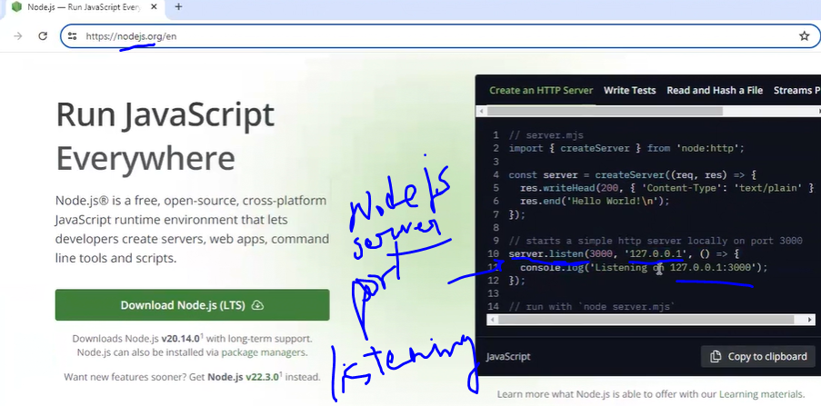

|  |  |
| --- | --- |
| C# IIS host | Typescript Node host |
| IIS hosts .Net websites  Eg. IIS host website  IIS only windows  Therefore .Net core evolved for NgINX | Node hosts Angular websites on node servers as well. Therofre powerful  Eg create servers and host websites  Node is cross plat Linux, windows |

Node is required to compile TypeScript ?

No node is not required compile. But Node is required to download the Typescript compiler

Ie. NPM (Node Package Manager)

NODE IS ONLY USED TO RUN MY JAVASCRIPT CODE.

NPM

-It helps to download the packages from repository.

Eg. To download jqueyr. With one command I can download

-It resolves Inter dependencies.

Eg. To run jquery we need xyz lib and for xyz it depends on abc. This interdepencies are resolved by NPM.

>npm install jquery

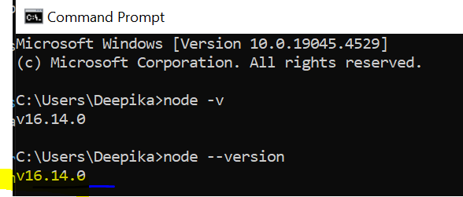

Latest version of Typescript on July 7 2025 is Typescript v 5.4

LOCATION where Typescript gets installed globally

**CMD:**

>npm install typescript -g

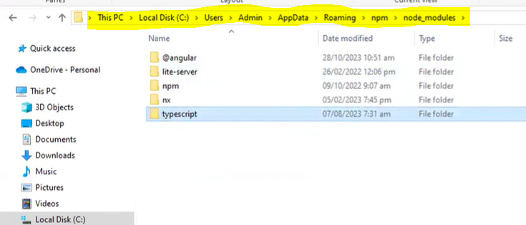

By default downloads the latest version, but to install a specific version we must specify it explicitly.

***TSC command :***

***>tsc firstsample.ts***

***This is going to compile the Typescript code to Javascript code.***

***TS code---(TSC)---> JS code***

* **Node firstsample.js**

***Input:***

var i=10; // in javascript possible

var i:number=10; //in typescript

var j:string="Deepika";

var z:any=10;

z=true;

//j=10;//error // not dynamic type

console.log(i);

console.log(j);

console.log(z);

***Compile: tsc***

***PS C:\Deepika\Azure Cloud\Angular\June2024-JS-TypeScript> tsc .\firstsample.ts***

***Execute: node***

***PS C:\Deepika\Azure Cloud\Angular\June2024-JS-TypeScript> node .\firstsample.js***

***In the .js file the code is interpreted differently from typescript.For eg, tt creates different set of variables.***

***Output :***

***10***

***Deepika***

***True***

***---------***

***Additional Info:***

***VS code editor is built using ELECTRON JS.The editor in the background is a browser. Javascript is very powerful.***

***--------***

***NodeJs is a javascript runtime built on Chrome’s V8 Javascript engine.***

*NodeJs is a big concept. We need one tool within the nodejs called node pkg manager.*

***Nodejs:***

*Javascript runtime- with this we can run typescript without browser.*

*We can run js code on server*

*Host application on node server*

*VS code is running on javascript -> electron js framework*

*Git-desktop is all electronjs*

***Typescript -🡪 Javascript***

***Typescript latest version 5.4.5***

**Node Package Manager (NPM):**

**Donwload packages from a public repository. Also, it resolves inter dependencies.**

NPM is a command line tool that installs, updates or uninstalls Node.js packages.

It will download it from online repository for open-source Node.js packages.

NPM is included with Node.js installation.

>npm install jquery

**NPM-downloads js/css packages from public repository (like nuget in .Net)**

**It resolves inter-dependencies.(by downloading the dependent pkgs)**

* **inter-dependencies means if jquery is dependent on other libraries, then that will also get downloaded.**

**Install npm globally**

1. **npm install -g typescript or -npm install typescript@4.8**

**It installs in C:\Users\Deepika\AppData\Roaming\npm\node_modules**

**(latest v 5.4.5)**

1. **C:\Deepika\Azure Cloud\Angular\DNT363-Sept8-JobInterviewPrep\Day2>tsc -v**

**Version 5.2.2**

1. **Tsc filename.ts**
2. **Node filename.js**

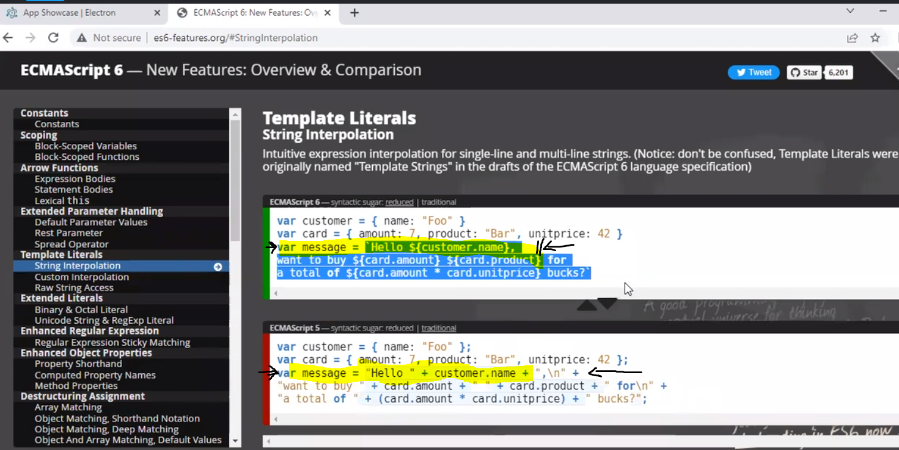

**Datatypes:**

|  |  |
| --- | --- |
| **Primitive types** | **Object Types** |
| **Number** | **Array** |
| **String** | **Tuple** |
| **Boolean** | **Interface** |
| **Void** | **Class** |
| **Any** | **Enum** |
|  | **Function** |

**Interpolation {}**

|  |  |  |
| --- | --- | --- |
| **ES5 string concatenation** | | **ES6 String Interpolation** |
| **Var str1=”Deepika”**  **Var str2=”Prasad”** | | |
| **Str3 = ”hi” + str1 + str2** | | **Str3 = ` ”hi” $ {str1} {str2}`** |
| **Syntax:** | **+varname** | **${} = $ {var name }** |
| **+** | | **${}** |
| **+ +** | | **${} ${}** |

|  |  |
| --- | --- |
| **Object oriented Javascript** | **TypeScript:** |
| **Support classes** | **Has C# related syntax**  **Eg. Tuples**  **New syntaxes** |
|  | **Its interpretation is javascript** |
| **Does not support datatypes** | **Supports Datatypes** |
| **Does not support Generics** | **Supports Generics** |
|  | **Wrapper around javascript**  **What does creating a wrapper around that code means?**  **In c# we have api. API is not exposed to the user directly. that is exposed to the user through a DLL. So in the DLL having the API call.** |
|  |  |

**Declarations**

|  |  |  |
| --- | --- | --- |
| **C#** | **JS** | **TS** |
| **Int a =0;** | **Var a=10** | **Var a : number =10;** |
|  | **Reassign :**  **a=”Deepika Prasad”**  **//no error** | **Reassign:**  **a=”Deepika Prasad”**  **//error: string is not assignable to a type number** |
| **Eg2**  **String b=”Samm”;** |  | **Var b : string = “Deepika Prasad”** |
| **Eg 3**  **Bool c = “true” ;** |  | **Var c : boolean = true ;** |
| **Eg 4:** |  | **Var z : any = 10 ;**  **//can be anything like string, number**  **z=”Deepika”**  **z=”true”** |

**Is going to have C# l**

function add(x:number,y:number):number ***🡨 return type***

    {

return x+y;

    }

console.log('Additon=',add(10,20));

**Only global concept and no local variable concept. Ie. Variable gets the latest value.**

**var a : number=100;**

**if(true)**

**{**

**Var a : number=100;**

**Console.log(a);**

**}**

**Console.log(a);**

**Interview questions:**

|  |  |
| --- | --- |
| **Var -global scope or function scope** | **Let -block scope** |
| **var a:number=10;**  **global scope** | **let b:number=20;**  **blocked scope , no hoisting is available** |

|  |  |  |
| --- | --- | --- |
| **Declaration type** | **Scope** | **Hoisting** |
| **var a:number=10;** | **global scope** | **Possible**  console.log(s);  *var* s=100;  **>node ./firstsample.js**  **Undefined**  **Eg.2**  for (var i1=0;i1<5;i1++)  {      console.log(i1);  }  console.log(i1);  //var scope is available  output:  0  1  2  3  4  5 |
| **let b:number=20;** | **blocked scope , no hoisting is available** | **Compiler error**  console.log(t);  ***let*** t=100;  - error TS2448: Block-scoped variable 't' used before its declaration.  **Eg2.:**  **for** (let i1=0;i1<5;i1++)  {      console.log(i1);  }  console.log(i1);  //let scope error outside loop  error TS2304: Cannot find name 'i1'. |

**If(true)**

{

**Var a:number=100;**

**Let b:number=200;**

**Console.log(a);**

**Console.log(b);**

**}**

**Console.log(a);**

**Console.log(b);**

**Ans:**

**Ture**

**100**

**200**

**100**

**20**

**Addition65**

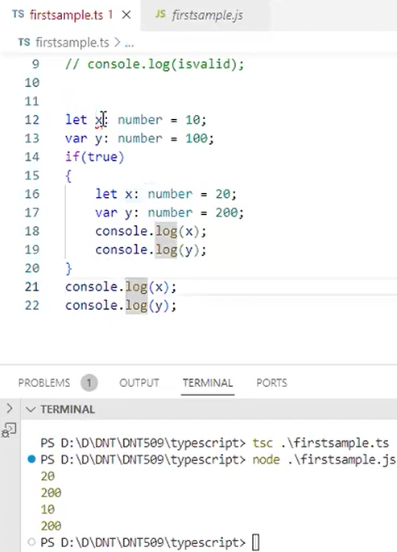

**Code Execution to see the results:**

|  |  |  |
| --- | --- | --- |
| **Compile** | **tsc firstsample.ts** | *.ts* |
| **Run or execute** | **node ./firstsample.js** | *.js* |

**C:\Deepika\Azure Cloud\Angular\DNT363-Sept8-JobInterviewPrep\Day2>tsc firstsample.ts**

**C:\Deepika\Azure Cloud\Angular\DNT363-Sept8-JobInterviewPrep\Day2>tsc firstsample.ts**

**C:\Deepika\Azure Cloud\Angular\DNT363-Sept8-JobInterviewPrep\Day2>node .\firstsample.js**

**10**

**In the below code**

**For( let i1=1;i1<5;i1++) { console.log(i1); } // let is block scope; it will only work insid ethis block**

**console.log(i1);//error ;since let is blocked scope**

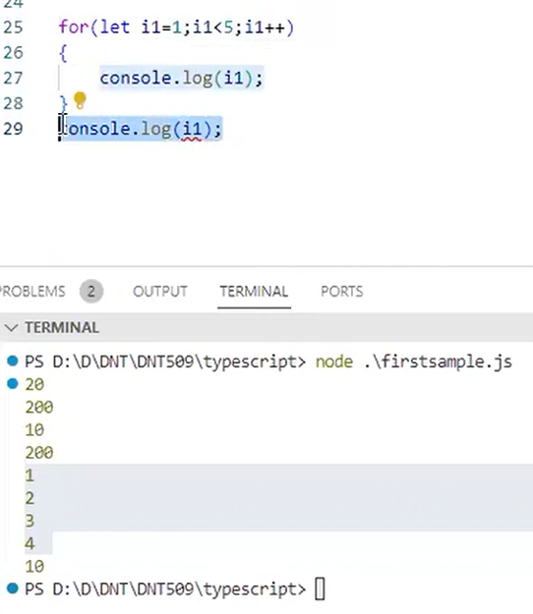

**Code Execution in ES5**

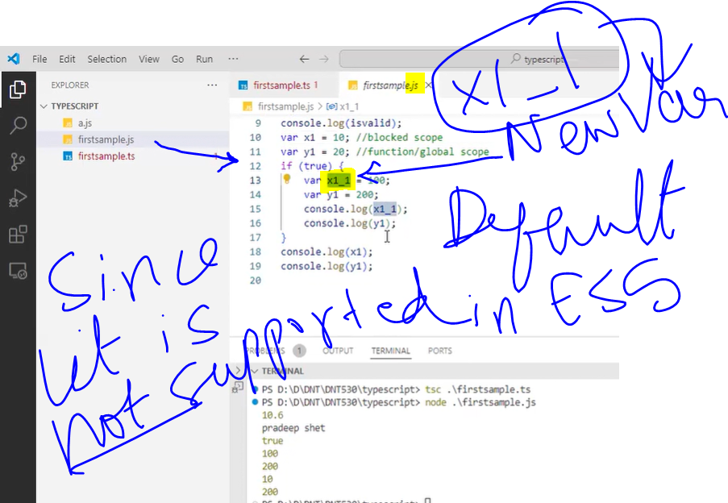

**Code Execution in ES6**

**>tsc .\firstsample.ts –target es6**

**PS C:\Deepika\Azure Cloud\Angular\June2024-JS-TypeScript> tsc .\firstsample.ts --target es6**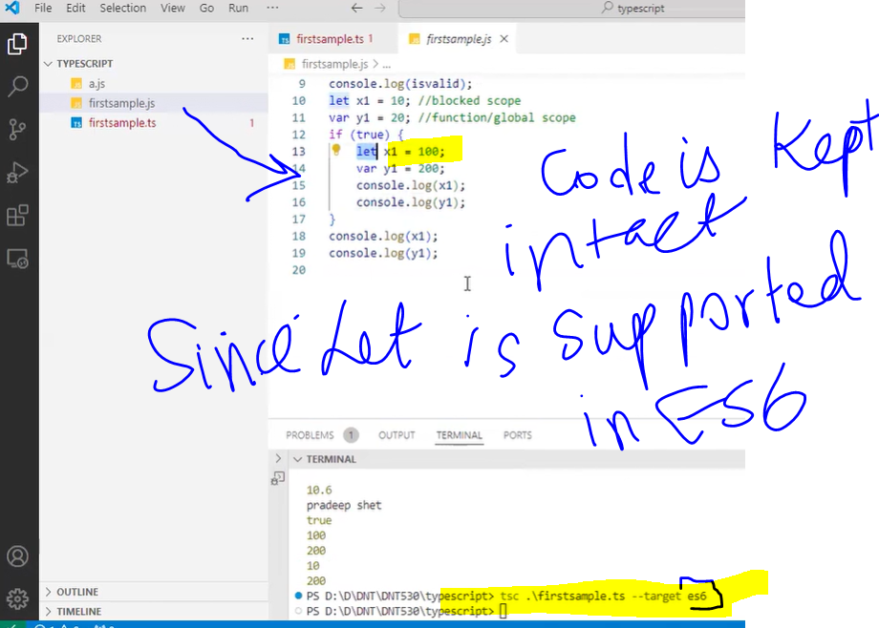

**Hoisting example:**

**Firstsample.TS**

console.log(q); //it will prompt for an error on IDE, but executes

//But the output iwll be undefined.

var q = 5;

output: undefined

**Hoisitng Screenshot below: It moves the declaration to the top**

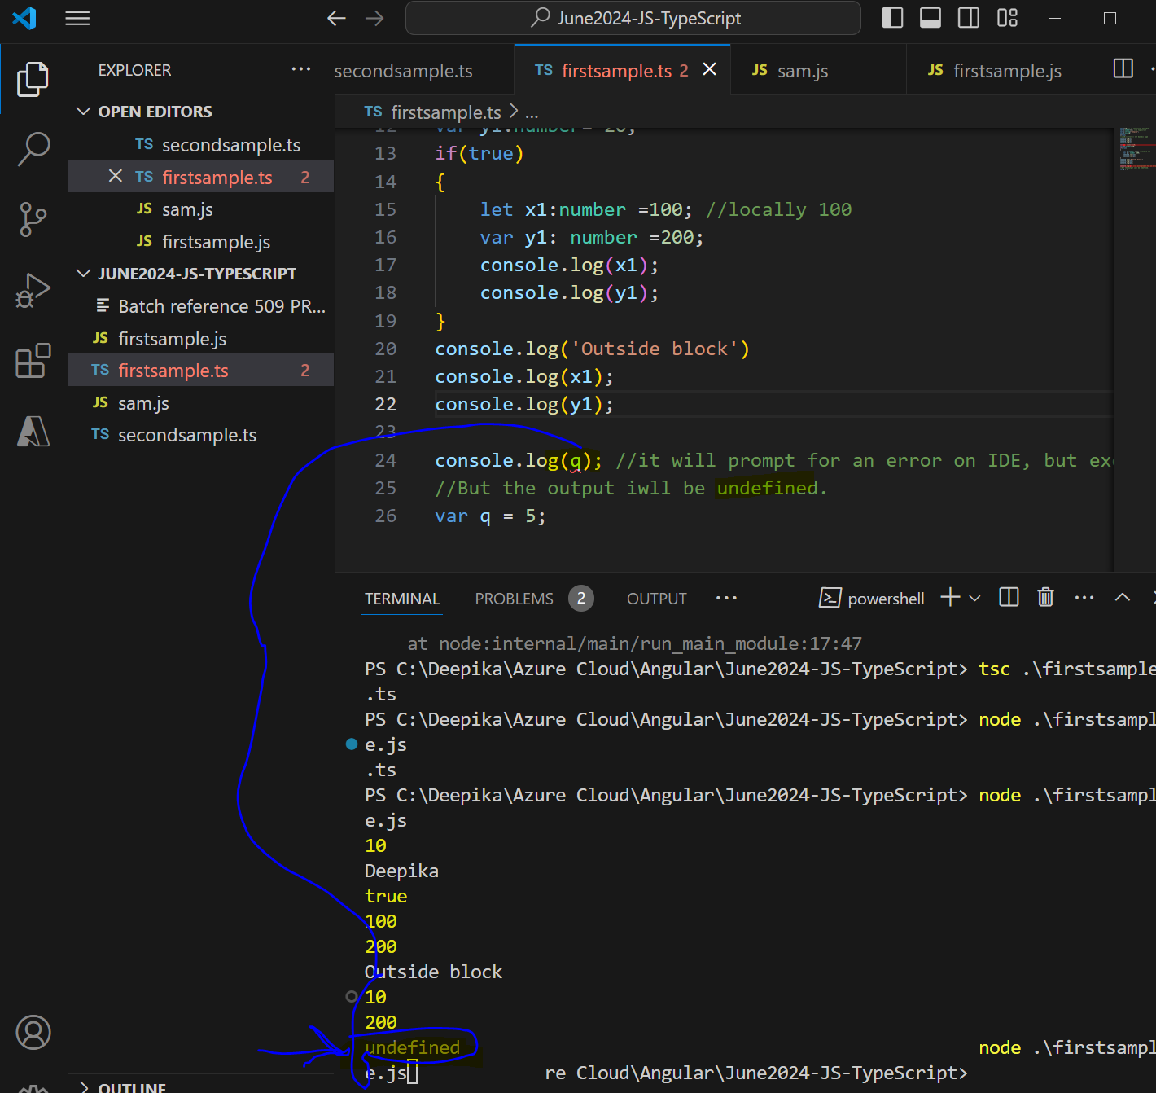

**Hoisting with let keyword will not work in typescript //error**

**Firstfile.ts**

//hoisting: using let keyword //throws a compiler error

console.log(r); //error //hoisting wont work with let keyword

let r=300;

**output:**

firstsample.ts:31:13 - error TS2448: Block-scoped variable 'r' used before its declaration.

31 console.log(r);

~

firstsample.ts:32:5

32 let r=300;

~

'r' is declared here.

Found 1 error in firstsample.ts:31

**Screenshot: hoisting for let leads to a compiler error in typescript**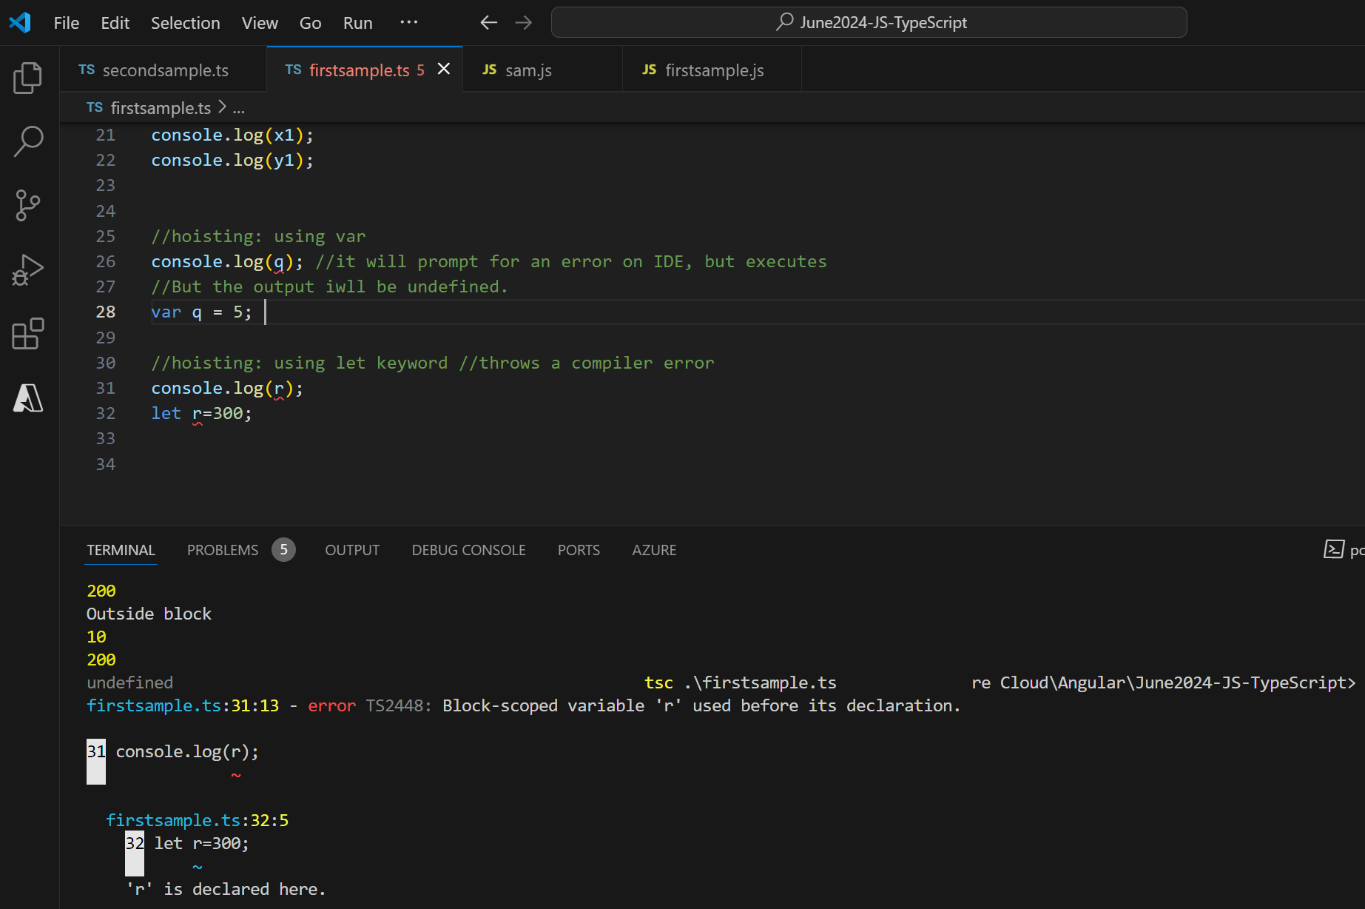

|  |  |
| --- | --- |
| **3 TYPES OF FUNCTION DEFINITIONS (REGULAR, ANANYMOUS, ARROW FUNCTION)** | |
| **REGULAR**  **FUNCTION** | //named function  function add(x:number,y:number):number  {      return x+y;  }  let result=add(1,2);  console.log('Total(Named)='+result); |
| **ANONYMOUS FUNCTION** | //anonymous function  var add1=function(x:number, y:number): number  {      return x+y;  }  let result1=add1(2,3); |
| **ARROW FUNCTION** | //arrow function  var add2=(x:number,y:number):number => x+y;  // (param:type):type  = function add()  // =>  = {return x+y}, |
|  |  |

|  |  |
| --- | --- |
| **Anonymous functions in C#** | **Anonymous functions in TyPESCRIPT** |
| **is to quickly create a function and when we do not want to use it again.** | **Purpose of Anonymous functions in C# Same in Typescript also Anonymous functions are for one time use.** |

**Anonymous functions:**

**- one time use**

**-simple syntax**

**Input of 3 types of functions**

//NAMED FUNCTION

function add(x:number, y:number) : number//number  return a

{

     return x+y;

}

//add(10); //demands 2 params

var result1=add(10,20);

console.log(`Result of named fn add(10,20)= ${result1}`);

console.log('Result =' + result1);

**//anonymous functions**

var add2=function(x:number, y:number) :number

{

    return x+y;

}

//how to an invoke anonymous fns

//var name(pram1,param2)

var result2=add2(30,40);

console.log(`Result of anonymous fn add2(30,40)= ${result2}`);

console.log('Result2=' + result2);

**//Arrow Function**

var add3= (x:number, y:number) :number  => x+y;

var resultarrowfn = add3(40,50);

console.log(`Result of Arrow Fn => ${resultarrowfn}`);

**Output of 3 types of functions**

**Result of named fn add(10,20)= 30**

**Result =30**

**Result of anonymous fn add2(30,40)= 70**

**Result2=70**

**Result of Arrow Fn => 90**

***This keyword: lexical scoping***

**Arrow function works differently than an normal function**

|  |  |
| --- | --- |
| **Normal function** | **Arrow Function** |
| **Let obj scope stays outside** | **Console.log(this.name takes let obj scope)** |
|  |  |
| So to carry let obj’s scope outside the loop, do the following:  To extend the scope of noraml function  Let self=this is used. |
|  |
|  |

|  |
| --- |
| **Var abc: any =100;** |
| **Var def: unknown=100;**  **def=test;** |

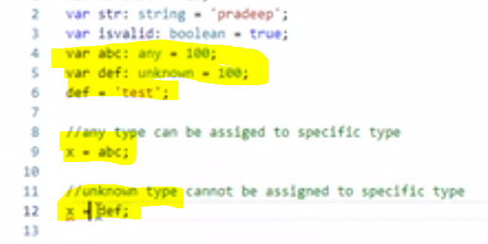

**ANY Datatype :**

1. **ANY datatype is like a poor guy or beggar; beggars cannot be choosers;**
2. **ANY will accept any datatype;**
3. **Note: we should avoid any; since it will allow any kind of data but if the code is not handling that it will throw an errors. ( eg, any will allow string or null, but if the code is not handling then it will lead to error). Therefore try to avoid any datatype**
4. **C# equivalent for ANY**

|  |  |
| --- | --- |
| **C# equivalent for ANY** | **ANY** |
| **Object type**  **Object will take int or string or boolean or null**  Public void function1(object objval)  {  // objval will allow string, int, boolean. So the control will come inside the function1.  // But the code should be able to handle the string or number or the boolean inputs.  //else the code will break  } | Var abc: any =100; //correct  Var def:any=”Shiv”//correct  Var ghi:any=true;//correct  Var jkl:any=undefined; //correct |

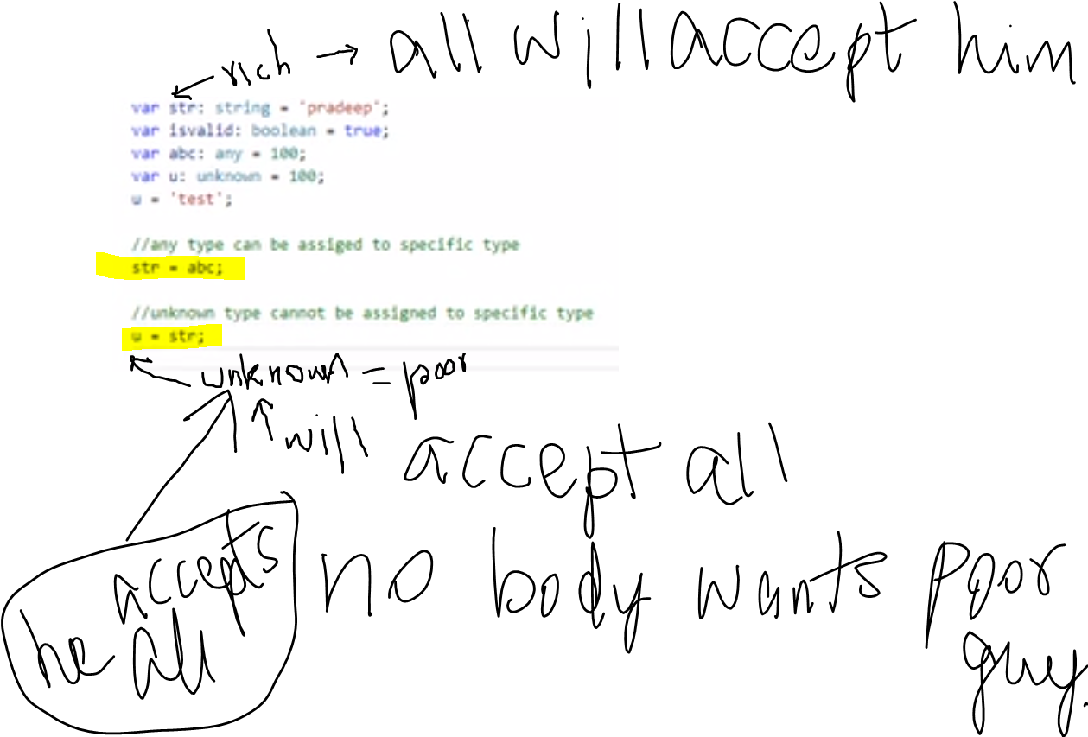

Discuss inheritance:

**Module**

|  |  |
| --- | --- |
| Export | import |
| export class Person {      PersonId: number;      Name: string; | import { ICustomer, add } from './icustomer';  import { Person } from './person';  export class Customer implements ICustomer  {      CustomerId: number;      constructor(cid: number)      {          this.CustomerId = cid;      }      showData():void{          let p = new Person();  //we cannot create an object without importing Person class  ….      }  } |
|  |  |

**Class:**

**Person.ts**

class Person

{

    personId:number;

    personName:string;

    constructor(pid:number,pname:string){

        this.personId=pid;

        this.personName=pname;

    }

    showInfofn () : void

    {

        console.log('Id=' +  this.personId);

        console.log('Name=' + this.personName);

    }

}

let personObj= new Person(1, "Ganesh");

personObj.showInfofn();

PS C:\Deepika\Azure Cloud\Angular\June2024-JS-TypeScript> tsc Person.ts

PS C:\Deepika\Azure Cloud\Angular\June2024-JS-TypeScript> node .\Person.js

**Output:**

Id=1

Name=Ganesh

**DATA TYPES:**

|  |  |
| --- | --- |
| Public (Default) | Only in that class |
| Private | Only available in child class |
| Protected |  |

**Function overloading in Typescript**

Function overloading in Typescript will not work. Reason is Typescript file will be converted to Javascript file.

|  |  |
| --- | --- |
| **Typescript** | **Javascript** |
| **Input :**  Function fn1(arg1:int, arg2: int, arg3: int) : int  { return arg1+arg2+arg3; }  Fn1(10,20,30)  Fn1(10,20)  Fn1(10) | **Input :**  Function fn1(arg1, arg2, arg3)  { return arg1+arg2+arg3; }  Fn1(10,20,30)  Fn1(10,20)  Fn1(10) |
| **Output:**  Typescript compiles to Javascript | **Output:**  Fn1(10,20,30) //60  Fn1(10,20) //nan  Fn1(10) //nan  Fn1() |

Finally, one Function named fn1(arg1,arg2,arg3) can be invoked by 4 function calls. for eg, Fn1(10,20,30), Fn1(10,20), Fn1(10), Fn1()

|  |  |
| --- | --- |
| **Function name** | **Invocation parameter list** |
| Function Fn1(arg1,arg2,arg3) | Fn1(10,20,30), //work  Fn1(10,20), //will not complaint  Fn1(10), //will not complaint  Fn1() //will not complaint |

**Javascript**:

fn1()

fn1(10) //10

fn1(10,20) //20

fn1(10,20,30) //50

**Result** : in javascript and typescript we cannot create functions with and without parameters cannot be overloaded. Thereofre overloading will not work or wont be supported.

Function overload and constructor overload will not work IN A normal way. It has to be handled differently.

//multiple constructor implementations are not allowed, but we can have multiple constructor definitions.

|  |  |
| --- | --- |
| **Normal Function overloading wont work** | **Normal Constructors overloading wont work** |
| fn1(); fn1(10,20,30);  Since a same function can be invoked with params fn1(10,20,30)  or without parameters fn1();  Consequently, we cannot have 2 different functions with a same name.  If Function1 is Name(),  then Function2 cannot be Name(‘Deepika’,’Prasad’). | constructor(){}  Error:Multiple constructor implementations are not allowed.ts(2392)      constructor(pid:number,pname:string)      {          this.personId=pid;          this.personName=pname;      }  Reason: If you have 2 constructors, any constructor would have been called.  That’s why Typescript errors if we create more constructors  Error name : Multiple constructor implementations are not allowed.ts(2392 |

How to handle the Function overloading and constructor overloading differently?

YES IT Function overloading and constructor overloading is possible

HOW?

|  |  |
| --- | --- |
| C# JAVA | Typescript |
| We can have multiple function implementations in the same function name in both C# and JAVA. | In typescript we can have many constructor definitions, but only one constructor implementation. |

In typescript we can have many constructor definitions, but only one implementation.

For eg,

How to achieve constructor overloading in typescript? Constructor definitions has to be given. And we have to provide only one contructor implementation with ?: in parameters.

**Example**: explaining the constructor implementation

constructor(pid ?: number, pname ?: string)

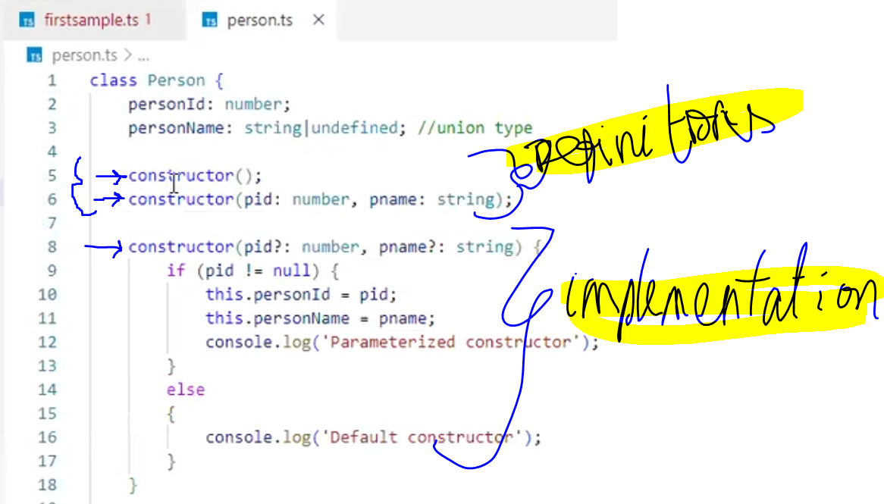

//I did not understand

class Person

{

    private personId:number;

   // public personName:string;

//Questions?why do we have undefined type? What is this type

    public personName:string|undefined; //union type; for constructor overload

//Union Type

let uniontypeArray : Array<string|number> = ["Champro","CHA",1,2];

    constructor(); //Multiple constructor implementations are not allowed.ts(2392)

    constructor(pid:number,pname:string);

    constructor(pid?:number,pname?:string)

    {

        if(pid != null){ //why do we need this line?

        this.personId=pid;

        this.personName=pname;

        console.log('Parameterised constructor')

    }

    else{

        console.log('Default constructor')

    }

    }

    showInfofn () : void

    {

        console.log('Id=' +  this.personId);

        console.log('Name=' + this.personName);

    }

}

let personObj= new Person(1,"Ganesh");

personObj.showInfofn();

? means undefined

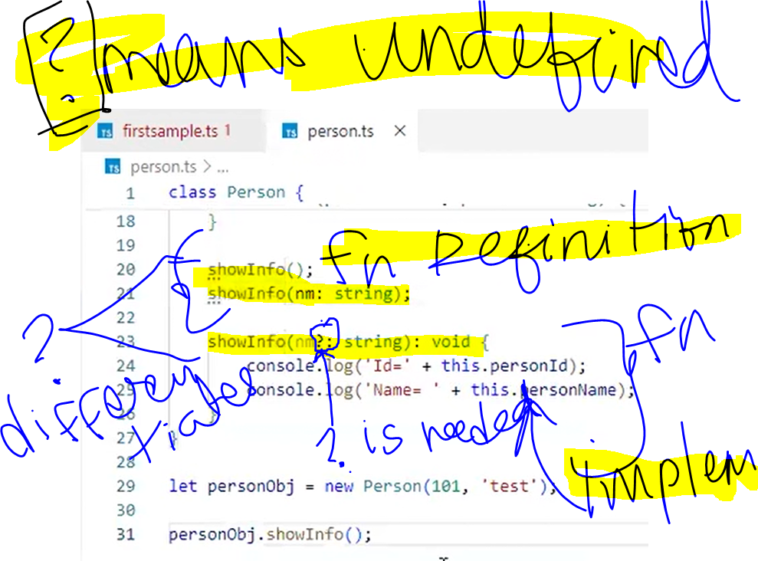

**For example:-**

let cloudname:string|number=123;

let containername:string|undefined="Azure";

let xyz:any=["abc","def",""]; //any will allow anythng like array or string or number or undefnined

let abc:any=undefined;//true//123//"abc"; //so should be avoided

|  |
| --- |
| //union type - Allowing more than one data type |
| let v : string|boolean = true; |

**Inheritance :**

**-inheritance. Child class should use super keyword to invoke parent class members**

class Employee extends Person  //extends keyword like JAVA for inheritance

{

    empId: number;

//constructor(){} //it would not work here ; it needs to explicitly say super() keyword.

    constructor()

    {

    //super();

    //explicitly calling your base constructor.

    super(2,'Sammi'); //now calling parent constructor's parameterized constructor

//write logic

}

    }

}

let empobj=new Employee();

**Class and Inheritance:**

class Person

{

    private personId:number;

   // public personName:string;

    public personName:string|undefined; //union type; for constructor overload

    constructor(); //Multiple constructor implementations are not allowed.ts(2392)

    constructor(pid:number,pname:string);

    constructor(pid?:number,pname?:string) //? means undefined

    {

        if(pid != null){

        this.personId=pid;

        this.personName=pname;

        console.log('Parameterised constructor')

    }

    else{

        console.log('Default constructor')

    }

    }

    showInfofn ();

    showInfofn (nm:string);

    showInfofn (nm?:string) : void

    {

        console.log('Id=' +  this.personId);

        console.log('Name=' + this.personName);

    }

}

let personObj= new Person(1,"Ganesh");

personObj.showInfofn();

**Inheritance:**

//inheritance in Typescript

class Employee extends Person  //extends keyword like JAVA for inheritance

{

    empId: number;

}

let empobj=new Employee();

empobj.

**Image of inheritance**

**Has extends keyword**

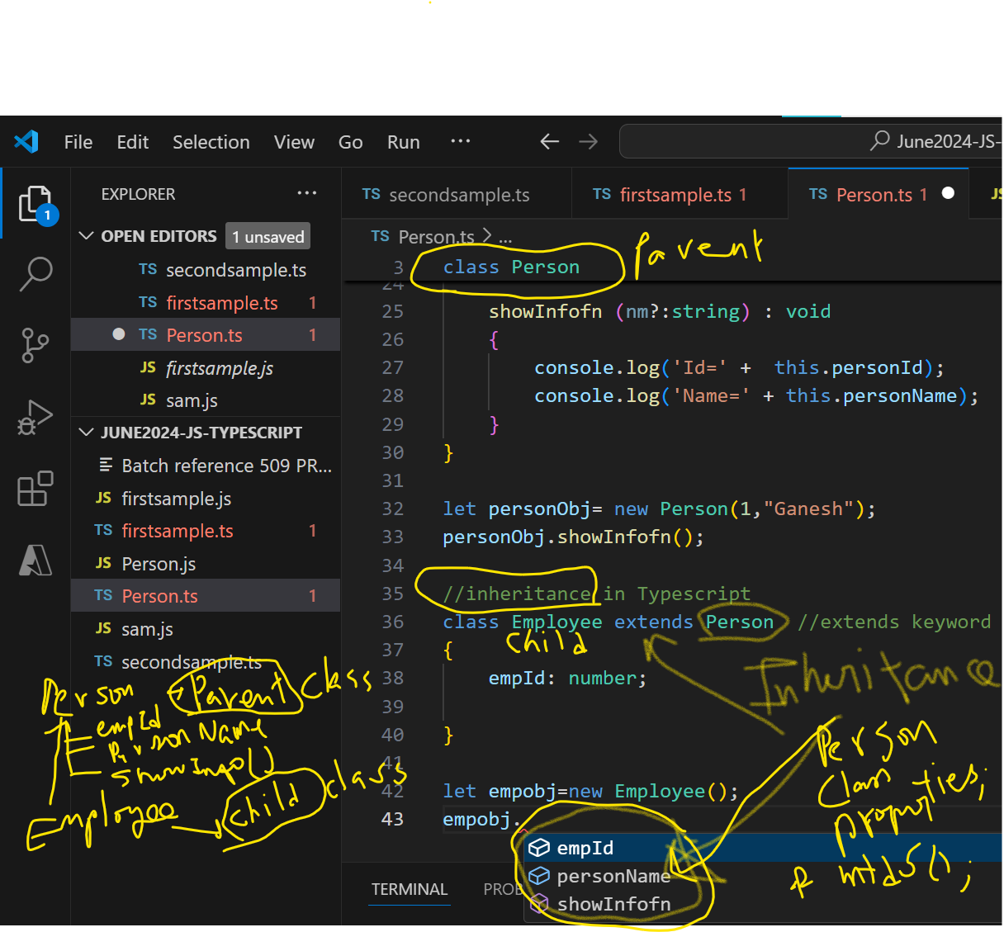

**When you call the child class or the derived class, your parent class object gets created first.**

**For Example, if a child is born in the world, the child’s parents must be available first.**

**In c#, if you create a child class, the parent class object gets created first.**

class Employee extends Person  //extends keyword like JAVA for inheritance

{

    empId: number;

//constructor(){} //it would not work here ; it needs to explicitly say super() keyword.

    constructor()

    {

    //super();

    //explicitly calling your base constructor.

    super(2,'Sammi'); //now calling parent constructor's parameterized constructor

//write logic

}

    }

}

let empobj=new Employee();

CLASS VS GENERIC CLASS

|  |  |
| --- | --- |
| **Class** | **Generic class** |
| export class Person  {      PersonId: number;      Name: string;      constructor();      constructor(pid: number);   constructor(pid: number, nm: string);  constructor(pid?: number, nm?: string) {          if (pid == null) {              console.log('Default constructor');          }          else if(nm == null)          {              console.log('1 Parameter constructor');          }          else {              this.PersonId = pid;              this.Name = nm ?? "";              console.log('Parameterized constructor');          }      }  showInfo();      showInfo(nm:string);      showInfo(nm?: string): void {          let cust = new Customer(123);          console.log(`Person Id=${this.PersonId}`);          console.log(`Person Name=${this.Name}`);      } | class Store<T>  //define T type =unknown still  {    private list: T[];    constructor()    {      this.list = [];    }    AddData(item: T)    {       this.list.push(item);       console.log('Item added');    }    DisplayItems(){      console.log('----Displaying items-----');      for(let it of this.list)      {           console.log(`Item=${it}`);      }    }  }  let store = new Store<string>();  store.AddData("red");  store.AddData("blue");  store.AddData("green");  store.DisplayItems(); |

***GENERICS:***

They are the classes that does not define the type while creating the class.

While creating an instance you provide that class type. So, the compiler will be clear that it needs only this type of data. In the same way, we can create a generic class

-This code discusses about Generic classes

* + How to cr a generic class
  + Generic class types
    - Type1: Generic Class that Accepts all the datatypes
    - Type2: Custom Generic class that accepts only specific datatypes
  + How to create a Generic Class type1 that accepts all the datatypes?
  + How to Generic class type (accepts any dataype) objects looks like? Will it take any datatype?

-2 Types of for loops

* + - * – for of & for in
      * -accessing for of

**How to create a Generic Class type1 that accepts all the datatypes?**

class Store<T>{

private list: Array<T>;

}

**How to Generic class type (accepts any dataype) objects looks like? Will it take any datatype?**

Yes generic class will accept any datatype (string, number, Boolean etc.)

//Generics type1: The class Store<T> can take any parameters.

let storeObject =  new Store<string>();

storeObject.addItemInStore("a");

storeObject.addItemInStore("b");

let storeObject1 =  new Store<number>();

storeObject1.addItemInStore(1);

storeObject1.addItemInStore(2);

for(let item of this.list)

        {

        console.log('Items are=' + item);

// for of here item is object

        }

for(let item in this.list)

    {

        console.log('Items are ='+this.list[item] );

//for in here list[item] is accessed from an array

    }

**Generics in Detail code**

**class Store<T>{**

**private list: Array<T>;**

constructor(){

    this.list = [];

}

addItemInStore(item:T)

{

    this.list.push(item);

    console.log('New item added' + item);

}

removeItemFromStore(){

    this.list.pop();

    console.log("Item removed");

}

//looping can be foreach loops- 2 types => for of , for in

displayRemainingItems()

{

    for(let item of this.list)

        {

        console.log('Items are=' + item);// for of here item is object

        }

    for(let item in this.list)

    {

        console.log('Items are ='+this.list[item] );//for in here list[item] is accessed from an array

    }

}

}

**//Generics type1: The class Store<T> can take any parameters.**

**let storeObject =  new Store<string>();**

**storeObject.addItemInStore("a");**

storeObject.addItemInStore("b");

storeObject.addItemInStore("c");

storeObject.removeItemFromStore();

storeObject.displayRemainingItems();

**let storeObject1 =  new Store<number>();**

**storeObject1.addItemInStore(1);**

storeObject1.addItemInStore(2);

storeObject1.addItemInStore(3);

storeObject1.removeItemFromStore();

storeObject1.displayRemainingItems();

**output:**

PS C:\Deepika\Azure Cloud\Angular\June2024-JS-TypeScript> tsc .\genericClass.ts

PS C:\Deepika\Azure Cloud\Angular\June2024-JS-TypeScript> node .\genericclass.js

New item addeda

New item addedb

New item addedc

Item removed

Items are=a

Items are=b

Items are =a

Items are =b

**//Next Topic: Spread Operator**

***LIST.TS***

***… 3 dots are important; … is called a spread operator; … creates a collection.***

//similar to params function in c#

// **Spread Operator**

function addition(a:number,b:number,...arr:number[])

{

    let result=a+b; //2, 3 is a, b and the rest are the array

    console.log(`"a is:" ${a} "b is:" ${b}`);

    for(let nos of arr){

        console.log(`"THe spread operator:" ${nos}`);

        result=result +nos

    }

    console.log("Result=" +result);

}

addition(2,3,4,5,6,7,8,9,10);// 2, 3 is a, b and the rest are the array

**output:**

PS C:\Deepika\Azure Cloud\Angular\June2024-JS-TypeScript> tsc .\list.ts

PS C:\Deepika\Azure Cloud\Angular\June2024-JS-TypeScript> node .\list.js

"a is:" 2 "b is:" 3

"THe spread operator:" 4

"THe spread operator:" 5

"THe spread operator:" 6

"THe spread operator:" 7

"THe spread operator:" 8

"THe spread operator:" 9

"THe spread operator:" 10

Result=54

"Items in anyArray are: " 1

"Items in anyArray are: " React

"Items in anyArray are: " true

"Items in anyArray are: " Software Developer

**List.TS**

**//how to push additional array to an existing variables using spread operator.**

let arr3:string[]=["summer","fall"];

arr3.push(...anyarray);

let concatenatedStr:string="";

for (let item of arr3)

{

     concatenatedStr=item;

    concatenatedStr=  concatenatedStr+item;

    console.log(`spread operator push array:  ${item}` );

}

**Output:**

spread operator push array: summer

spread operator push array: fall

spread operator push array: 1

spread operator push array: React

spread operator push array: true

**Generic Arrays and Union Type**

//how to define an array// array can take string or number or any datatype. It is a problem

//a Generic array

let arr=[1,"Shiv","Sammi",true,undefined]

//it can also be of array type

let strarray : Array<string> = ['React','C#','SQL','Javascript','.Net API'];

let anyarray : Array<any> = [1,"React",true]

anyarray.push("Software Developer");

**//Union Type**

let uniontypeArray : Array<string|number> = ["Champro","CHA",1,2];

**//in Union Type we can also create object of classes**

let uniontypeObjectPerson : Array <string|Person>=['a','b', new Person()]

|  |  |
| --- | --- |
| Topic | //destructuring |
| Spread operator …  let [r,g,b1,...remainingColors] = colors; | let colors = ["Red","Green","blue","black","brown"];  let [r,g,b1,...remainingColors] = colors;  console.log(r);  console.log(g);  console.log(b1);  for(let c1 of remainingColors)  {      console.log(c1);  } |
|  | let books = [{bookname: "C#", bookid: 101}, {bookname:"Angular", bookid:102}];  let [csharpbook, angularbook] = books;  console.log(csharpbook.bookname); |

Next Topic:

Class & Interfaces

interface ICustomer{

    showInfo();

   // mailInfo();

}

-class inherits another class //multiple inheritance like Java

-class implements Interface. We have to implement all the methods of interface in the implementing class.

class Customer implements ICustomer{

    //inside a class we do not need var and let keywords; since by default it is public

    //if these properties are outside the class we need the var and let

 customerId:number|undefined;//default public

 customerName:string|undefined;//default public

constructor()

{

    console.log('construcor executed');

}

showInfo():void{

    console.log(`Customer Id= ${this.customerId}`); //this keyword is mandatory

    console.log(`Customer Id= ${this.customerName}`); //this keyword is mandatory

}

}

PS C:\Deepika\Azure Cloud\Angular\June2024-JS-TypeScript> tsc .\Customer.ts

Output: **surprisingly error!**

Customer.ts:5:27 - error TS2552: Cannot find name 'ICustomer'. Did you mean 'Customer'?

5 class Customer implements ICustomer{ Customer.ts:5:7

5 class Customer implements ICustomer{ 'Customer' is declared here.

Found 1 error in Customer.ts:5

**Reason**:

EACH TYPESCRIPT FILE ACTS LIKE A MODULE. Customer Typescript file is not able to access the ICustomer file or module. Ie. Customer.ts is not able to access any files outside including the ICustomer.ts

Means it does not know what is going outside Customer.ts file.

**Next steps: How to access other files or other modules? This introduces us to the concept of modules.**

1.Export the Interface

2.Import the Interface in the class file

**Look at the changes:-**

1.Export the Interface

export interface ICustomer{

    showInfo();

   // mailInfo();

}

2.Import the Interface in the class file

***-Now customer class is knowing that there is a dependency on ICustomer.ts***

***-Also, there will be an ICustomer.js generate along with Customer.js***

***-Note: In case of dependencies it has to get downloaded first for the class to work.***

import { ICustomer } from "./ICustomer";

class Customer implements ICustomer

{

}

Also, //if you have additional functions in ICustomer.ts to be used throughout the app, then EXPORT the function

**ICustomer.ts**

export function CallMefn()

{

    console.log('fn impl');

}

**Customer.ts**

import { ICustomer, CallMefn } from "./ICustomer";

class Customer implements ICustomer

{

}

Dependencies are downloaded when the files are compiled. Tsc .\customer.ts

NOTE: When I compile the files, Javascript downloads the dependencies it the modules are exported and imported respectively.

**Module loader:**

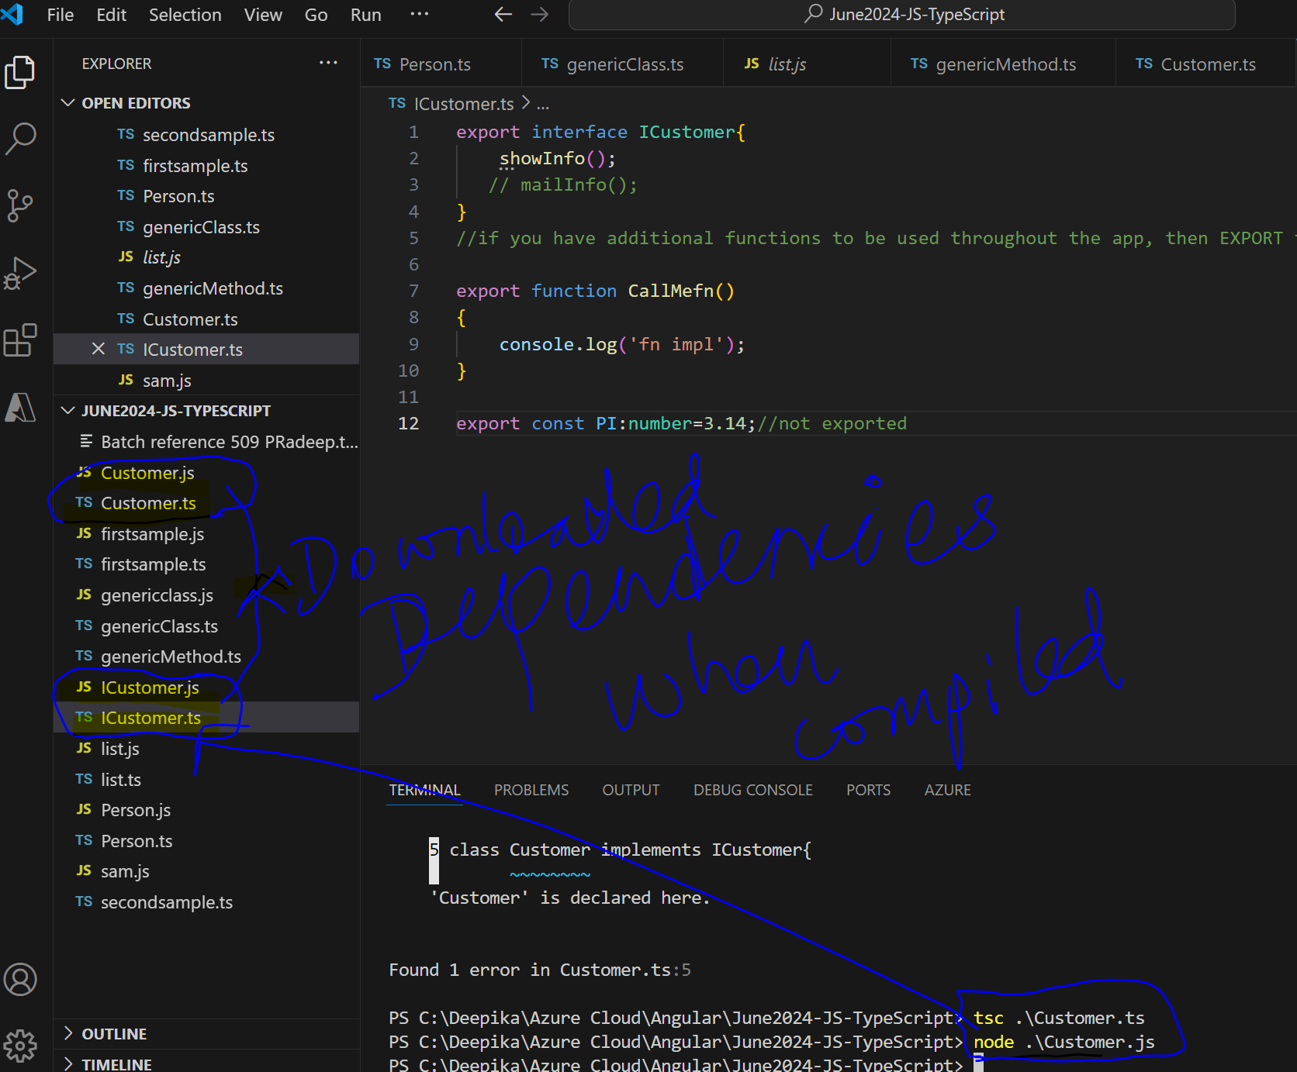

**Customer.js**

var ICustomer_1 = **require**("./ICustomer");

The require keyword will download the ICustomer.js file, since it is dependency.

REQUIRE JS is a concept is a project to standardize the module ecosystem for Javascript outside of web browsers.

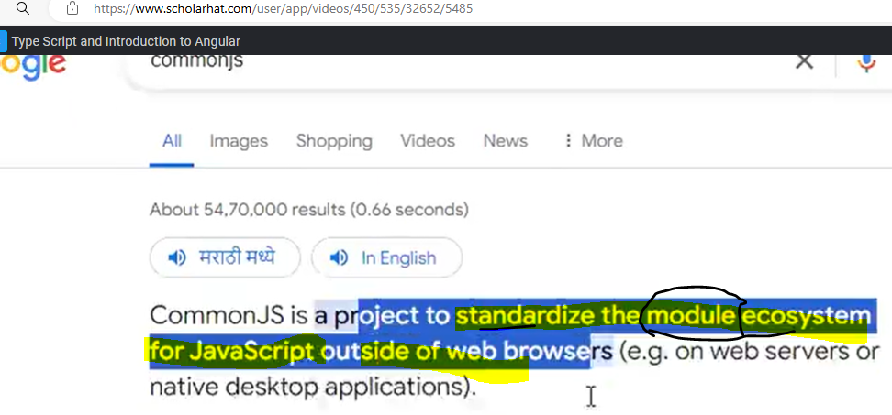

We can also create interdependencies among files.

For example,

**Person.TS**

export class Person

{ }

**ICustomer.ts**

import { Person } from "./Person"; //import person

export interface ICustomer{

    showInfo();

}

export function CallMefn()

{

    let pobj=new Person(); //create person object

    pobj.showInfofn();

}

Customer.ts (depends on) 🡪 ICustomer.ts (depends on) 🡪 Person.ts

If I compile Customer.ts-> it will download ICustomer.js and Person.js.

**Module loader** will download all the dependent javascript files. It’s a important concept in Typescript. Module loader dynamically downloads the js files at the runtime only at the click of the button.

It is similar to Node.js downloading all the interdependencies.

Similarly same concept is used in Typescript with Export and Import keywords. When using it

**MODULE FORMAT in JAVASCRIPT**

There are various module formatters available AMD=Asynchronous Module Format; UMD= Universal Module Format.

These are all the old techniques: These are js files but we can still see the export and import as it is.

**Module Javascript ES6:**

**INPUT**:

>tsc Customer.ts --target es6 --module system

>tsc Customer.ts --target es6 --module es6

**Ouput**: adds exports to the file

Exports_1(“Customer”,Customer) in Customer.js file

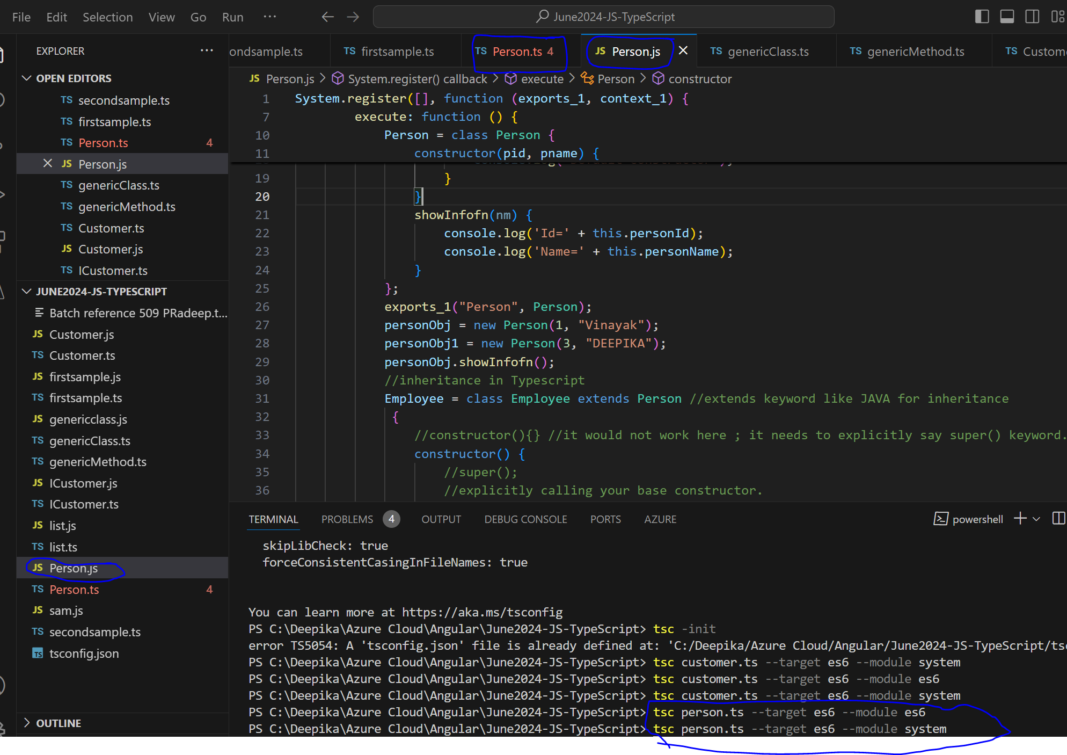 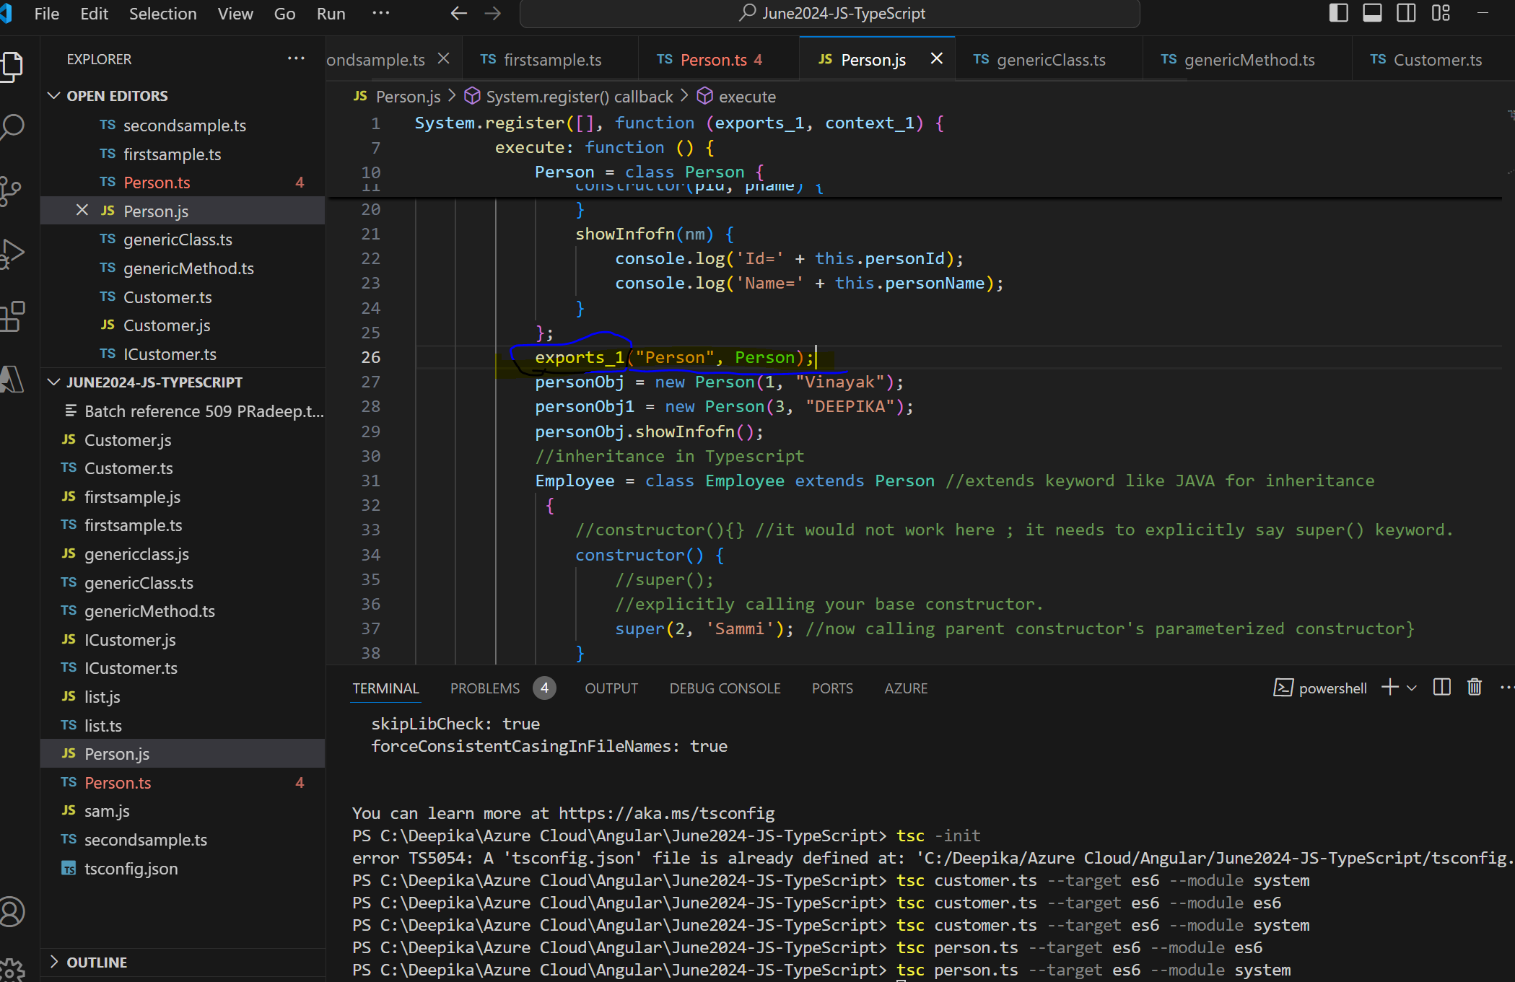

Exports_1 keyword is added to the file.

**AFTER CHANGING TARGET: “ES 6” & run tsc command Initially we will get errors but later see how to solve it?**

**-in tsconfig.json file 2 crucial things are “module” and “target”.**

**Later, strict is needed to be seen**

**>** "module": "ES6",

**>”strict” : “true”**

**And retain,** "target": "es2016",

**Why in tsconfig.json file module and target are crucial?**

**Tomorrow, if we have to generate the code according**

**“target” : “es2020”. Because I have upgraded the compiler and then changed the target and the module. The code that I have written 10years back should still work. Since the job of the Typescript compiler (tsc) is to translate the syntaxes and give the js. If it is not supporting, it will create an alternateive and create the syntax for that.**

Next, goto **tsconfig.json** file.

**INPUT :** Update the **"module": "ES6”**

**Terminal: >TSC**

**It will search for TSConfig file execute and leads to errors.**

**Output: We can see all the errors.**

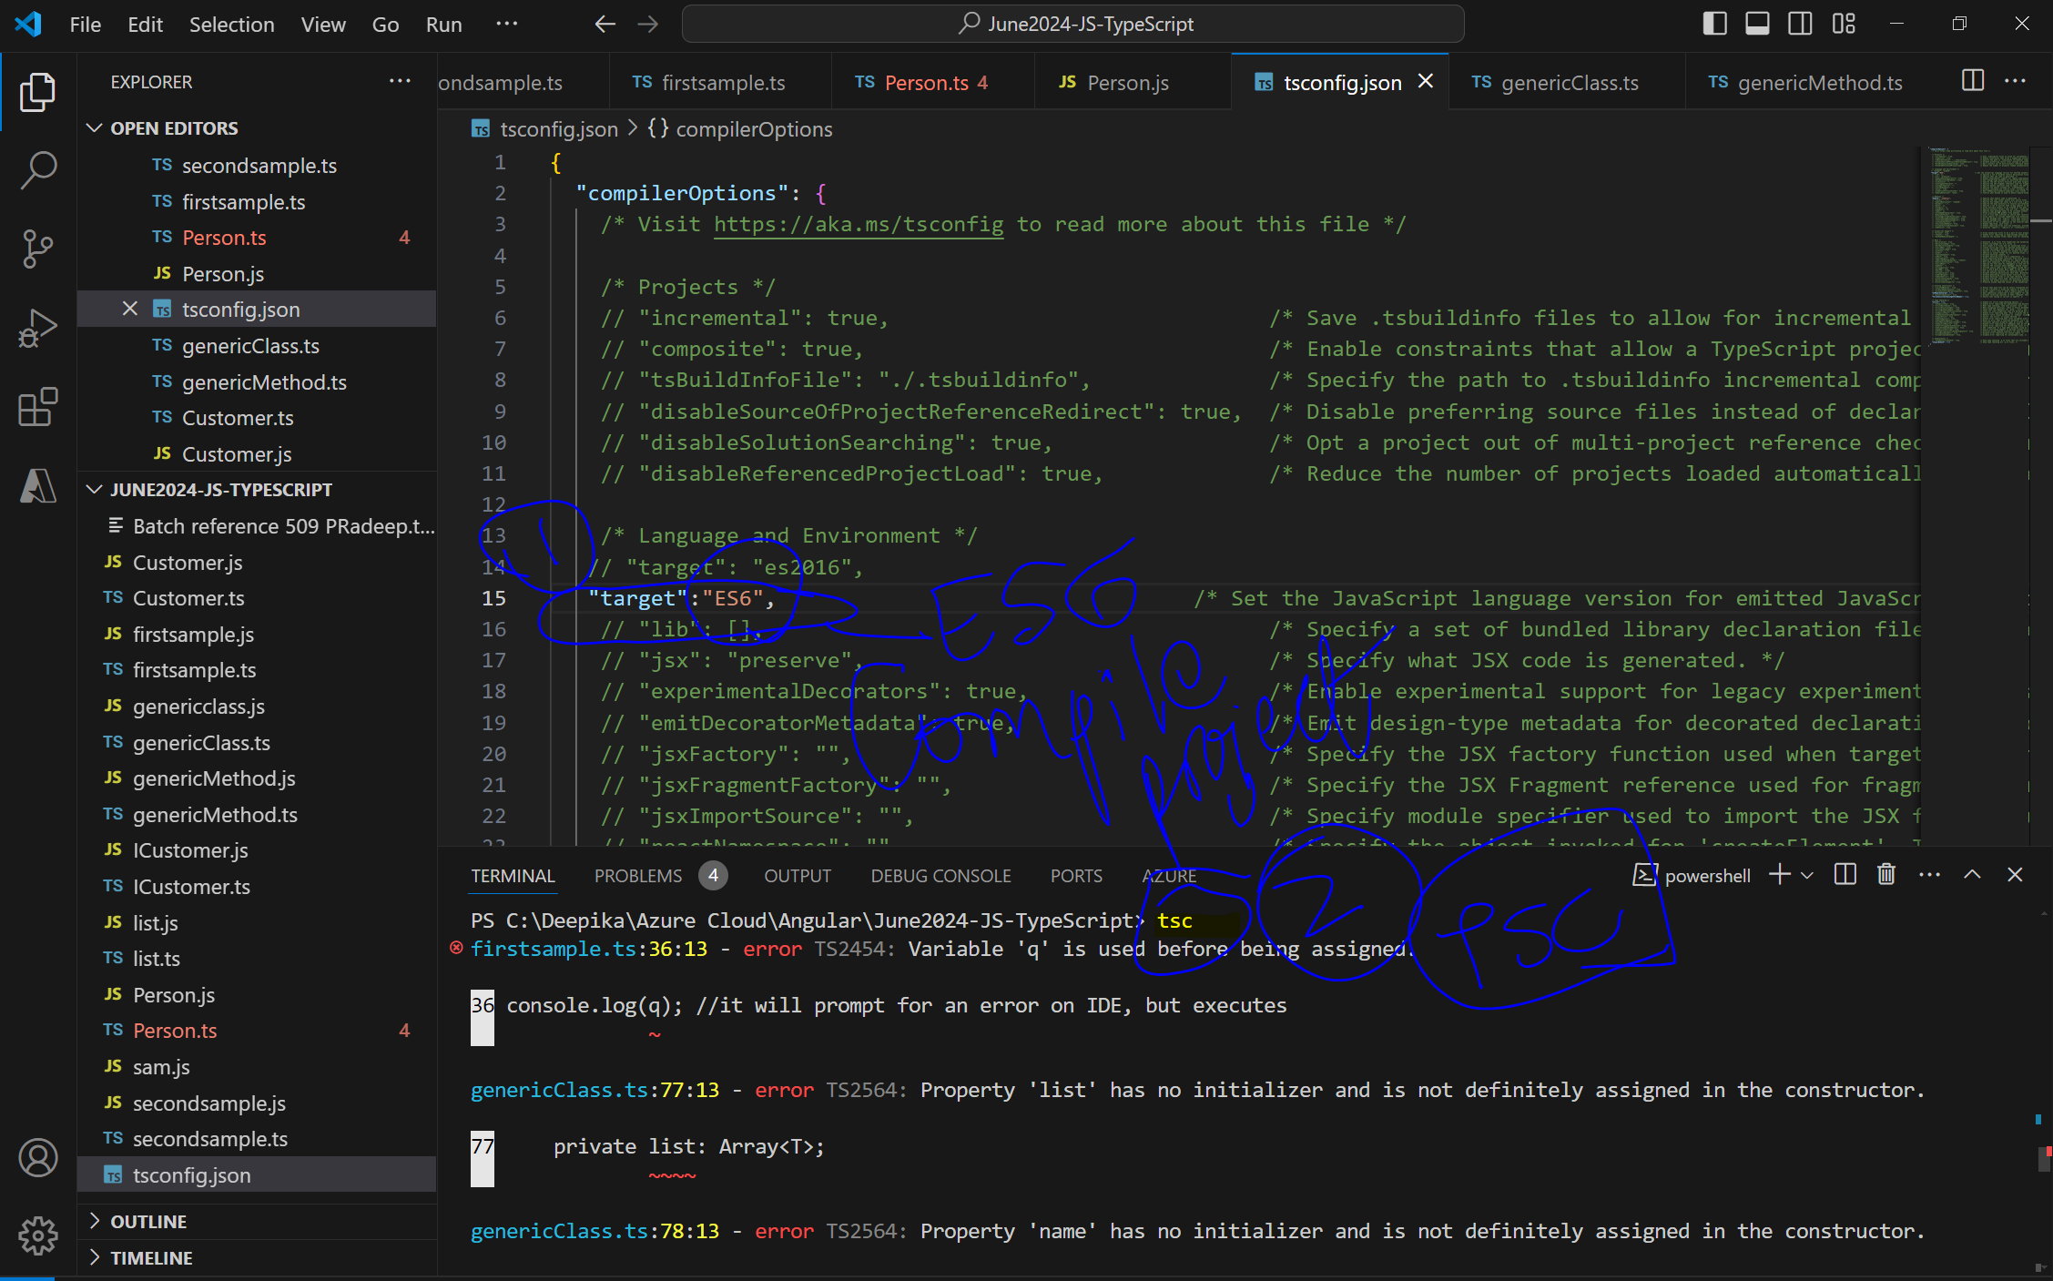

**Input**:

>TSC command

>tsc

Lets understand what are the errors? Ans: “STRICT” : “true”

Checks for syntaxes

//hoisting issue

firstsample.ts:36:13 - error TS2454: Variable 'q' is used before being assigned.

36 console.log(q); //it will prompt for an error on IDE, but executes

~

genericClass.ts:77:13 - error TS2564: Property 'list' has no initializer and is not definitely assigned in the constructor.

77 private list: Array<T>;

~~~~

genericClass.ts:78:13 - error TS2564: Property 'name' has no initializer and is not definitely assigned in the constructor.

Now, how to resolve this error?

*The reason for the errors shown up is because the “strict” : “true”*

At the end it is javascript. But javascript does not have to return type. Even without return type it is going to work.

It checks to see if it is returning a proper syntax or not.

**ES6 will not compile with syntax errors and with “strict”:”true”**

**But after fixing all the errors, >tsc command compiled.**

**FINALLY TSC compiled.**

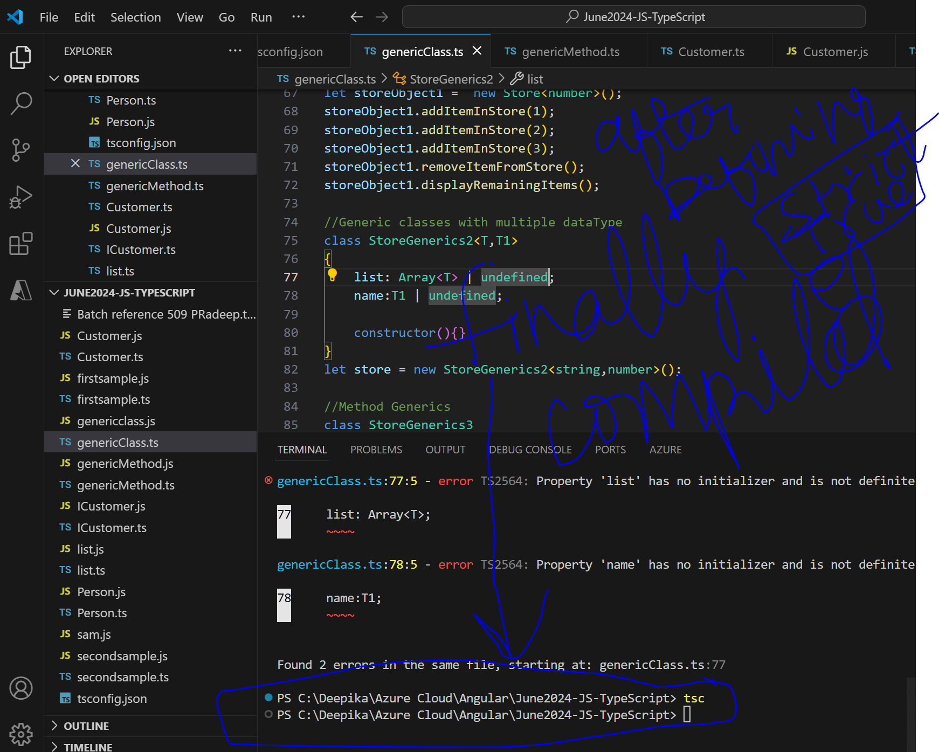

**OTHER Settings:**

 "outDir": "./outputFiles",

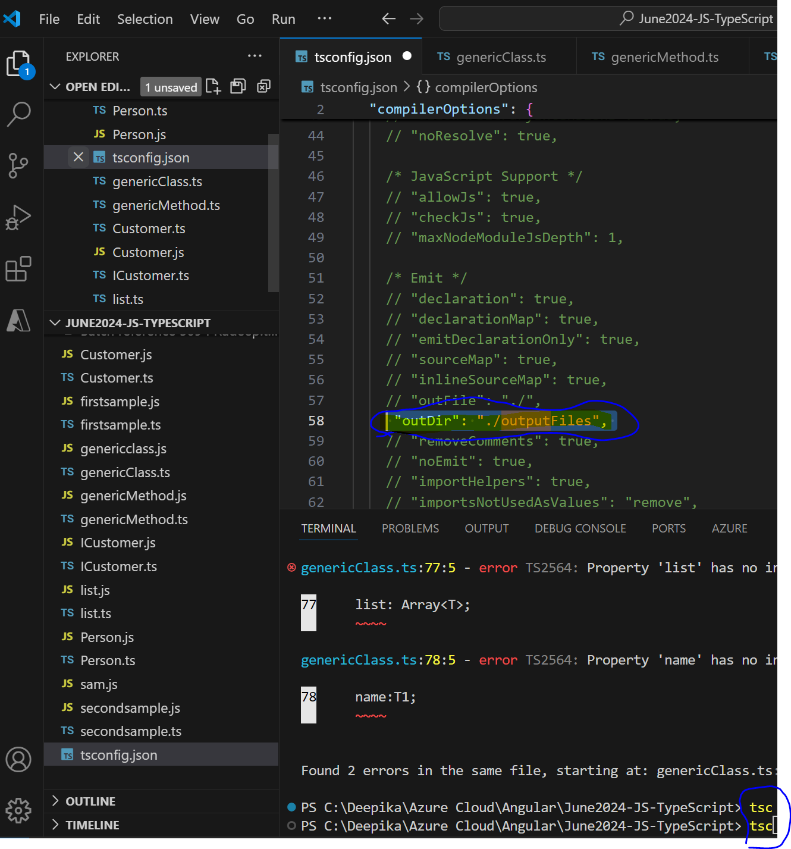

**Tsconfig.json**

**Adding tsconfig.js**

>tsc -init

Compile ts file with specific target

**TSConfig.json file is created:-**

Input: tsc -init output: tsconfig.json file is created

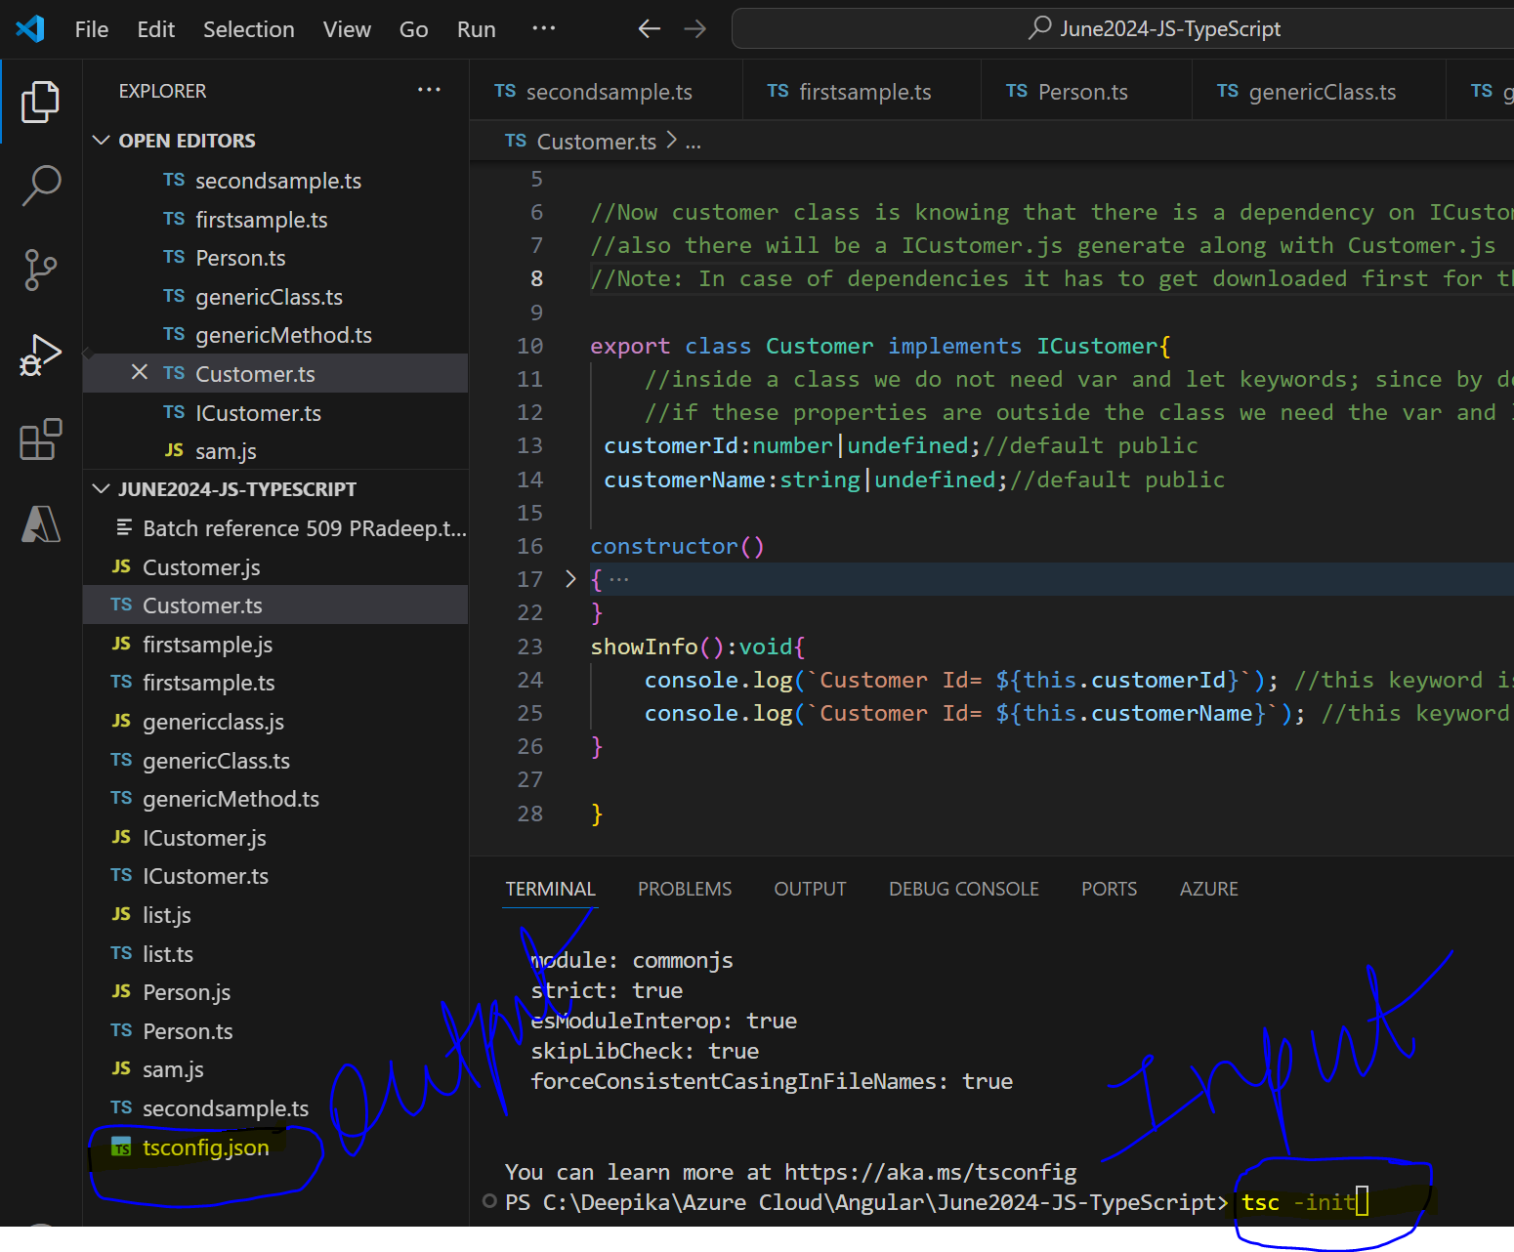

>tsc filename.ts -target es6 -module system

>tsc filename.ts -targe es6 -module es6

~~>tsc filename.ts -target es6 -module commonjs~~

|  |  |
| --- | --- |
| **2 important settings in tsconfig.json file** | |
| Module: es6 |  |
| outDir: “/.output” |  |
| Output director again |  |
| Remove commented codes |  |

**Input** command : tsc

Input: also, in tsconfig.json file, **“outDir” : ”./ouputFilesDeepika”**

**Ouput**: All the javascript files are generated inside the folder called “outputfilesDeepika”

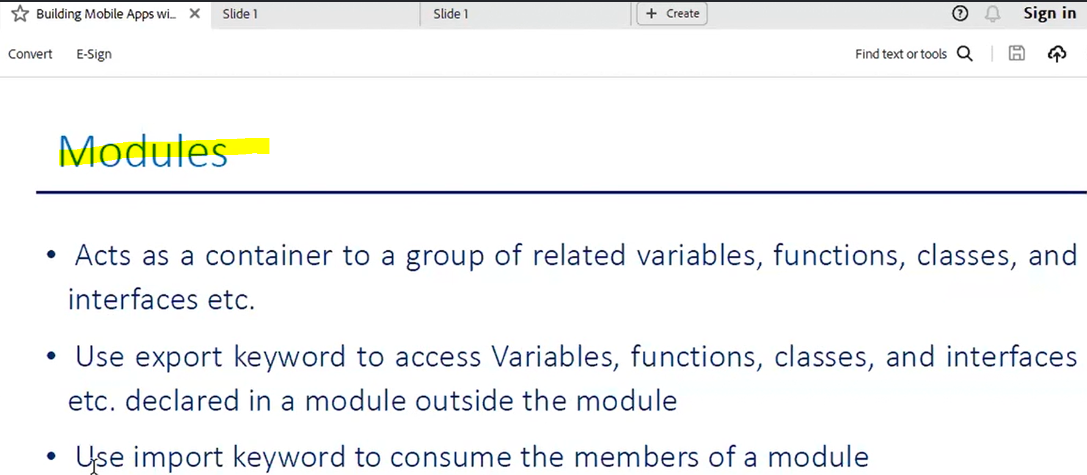

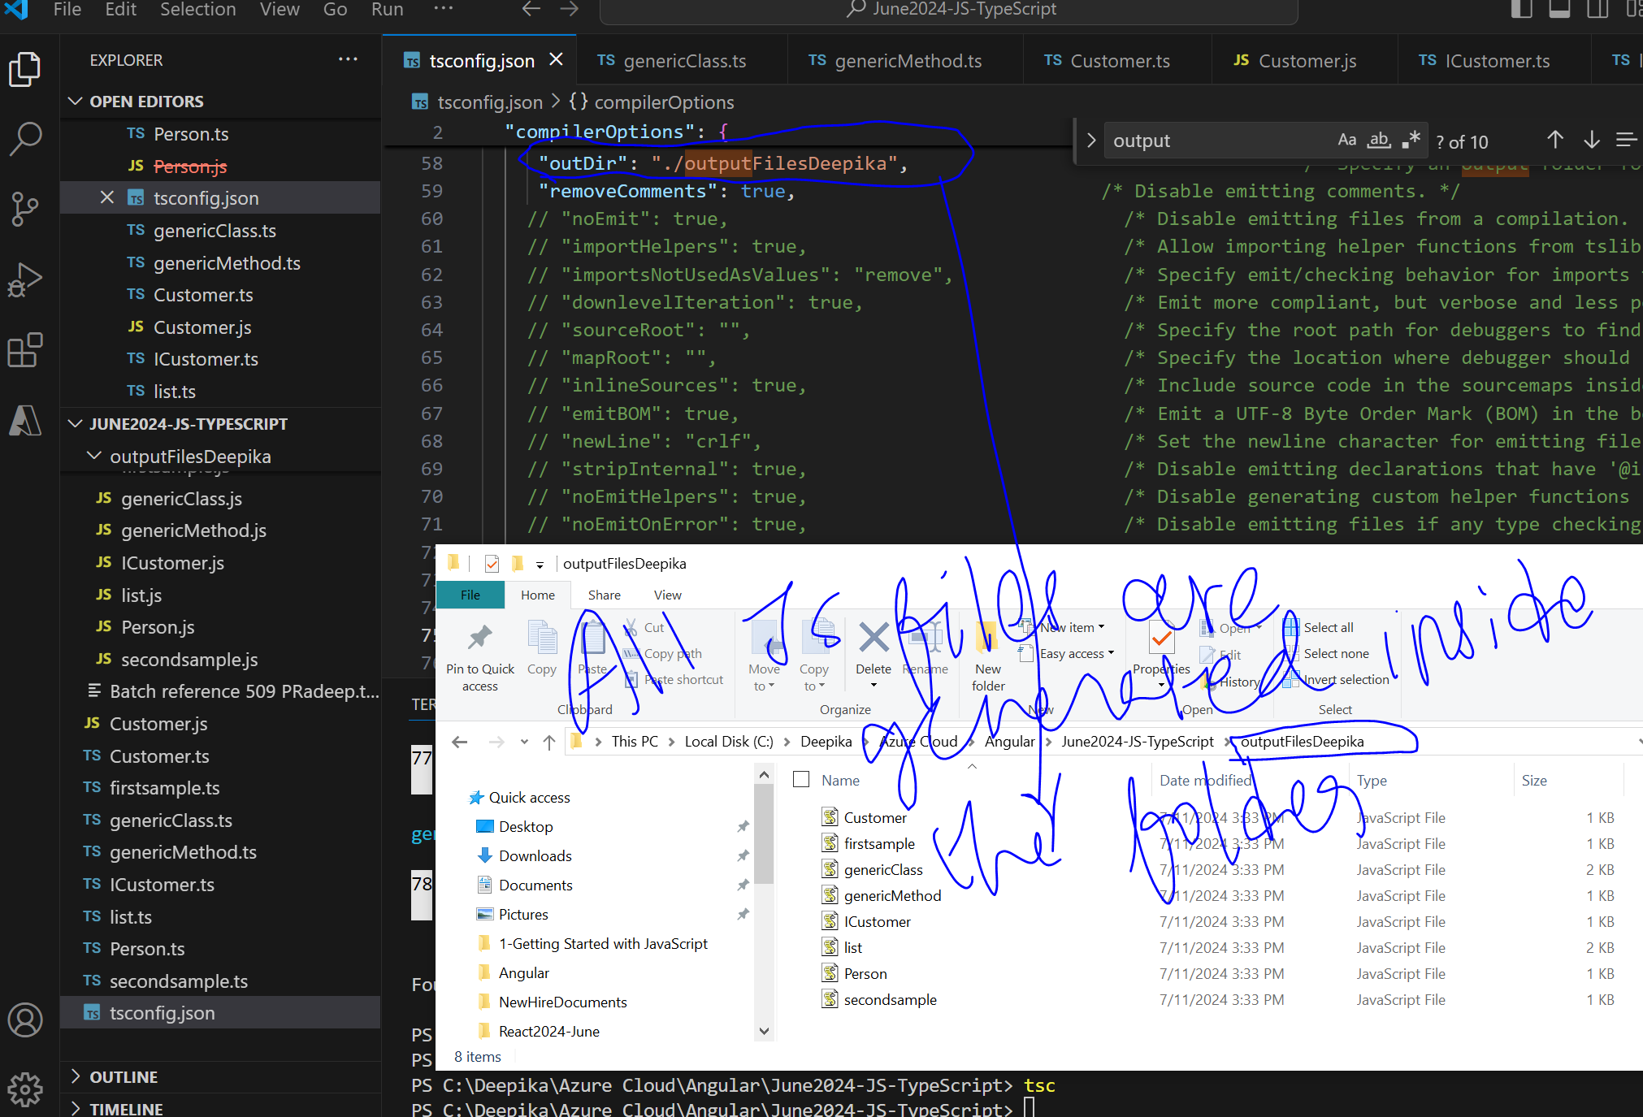

**Promise**:

Syntax:-

const promise = new Promise((resolve,reject) => {....});

-what is Async computation: whenever you execute a logic. It will execute step by step. However, if one of the step’s executions is taking longer. The control should get transferred to a separate thread.

-Promise has 2 API methods called as **THEN and CATCH**

-In Async, whenever I execute any logic, all the logics get executed sequentially in (step1-> step2-> step3)

For Eg,

1.Step 1

2. Step 2 -If step2 is taking more time; then my screen will be blocked until step2 is completed. So, the step2 should be transferred to a separate thread. That is the purpose of the promise. Once Step2 is completed the response will come back in the form of a Promise object.

Promise object will promise that, Once I have completed the execution, I will have the response ready. Just give me a way to give the response.

But in the meantime, the main execution will be continued with the next step ie step3.

1. Step 3:

-Promise works with ES6 syntax

-If you know AJAX, you should know Promise

Deepika Questions:-

**In Promise<string>, why do we have <string>?**

ChatGPT Answer:

In Promise<string>, the <string> is a type parameter that specifies the type of the value that the promise will resolve to. Generic type 'Promise<T>' requires 1 type argument(s).

### **Explanation :**

A Promise is a built-in JavaScript object that represents the eventual completion (or failure) of an asynchronous operation and its resulting value. In TypeScript, you can specify what type of value a promise will eventually yield using generics.

* Promise<T>: This is a generic type, where T represents the type of the value that the promise will resolve to.
* Promise<string>: In this case, T is string, meaning the promise will eventually resolve to a value of type string.

**Promise.ts**

//promise - used to have async computation

//Promise object promises that It will return either +ve response or returns a negative response.

//api methods => then, catch

//Then will return either positive response

//catch will return a negative response.

//Promise<T>//returns only datatype mentioned here

function GetData(data: string): Promise<string> {

    //every promise object has 2 blocks,

a. resolve-positive output,

b. reject-negative output

  let p = new Promise<string>((resolve, reject) => {

    setTimeout(() => {

      console.log("step2");

      if (data.length > 7) {

        resolve("Data=" + data);

      } else {

        reject("Error in Length");

      }

    }, 5000); //5seconds

  });

  return p;

}

//then api method; catch api method

console.log("step1");

GetData("DeepikaPrasad")

  .then((resp) => {

    console.log(resp);

  })

  .catch((err) => {

    console.log("Error", err);

  });

console.log("step3");

**Output:**

PS C:\Deepika\Azure Cloud\Angular\June2024-JS-TypeScript> node .\promise.js

step1

step3

step2

Data=DeepikaPrasad

Qn: What is default access modifier in angular

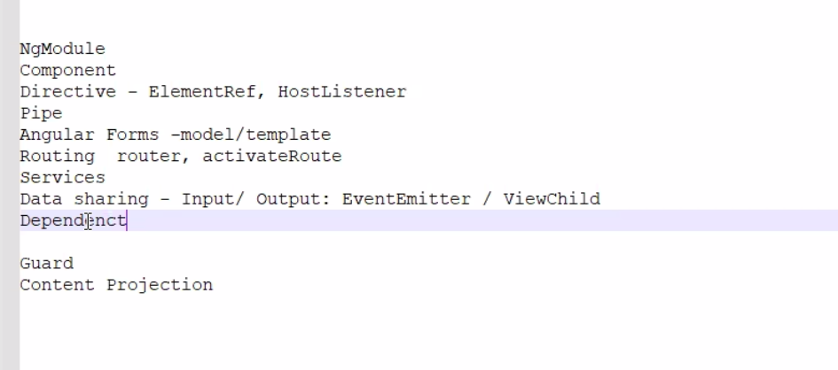Document.getElementById(‘txt’).value=”Sammi”

$(‘#txt’).val(‘Sammi’)